10/29/2020

By Oliver Mamuda

Candidate Number: 6086

Center Name: Bristol Grammar School

Center Number: 50419

Qualification Code: H446

Date: 10/29/2020

Webpage Ranking for Search Engine Optimization

OCR A Level Computer Science Project

Contents

**Analysis** 3

The Problem 3

Identifying the Problem 3

Why a Computational Approach? 3

My Computational Methods 4

Stakeholders 5

Who Are They? 5

The Solution for Stakeholders 5

Research 6

Can I Rank: Competitor Analysis 6

Ahrefs: Rank Tracking 7

Pro Rank Tracker 8

Interviews 8

Essential Features 11

Hardware and Software Requirements 11

For Me 11

For my Users 12

Requirements 12

Requirements Specification 12

**Design** 15

Decomposition 15

Top-Down Design 15

Flowchart overview 16

Explanations and Justifications 17

User Interface 34

Login / Signup 34

Predicted Rankings and SERP 35

Usability and Accessibility 37

Key Variables and Data Structures 37

Data Collection 37

Testing 39

Post Development Testing 40

**Implementation** 41

Data Collection 41

Getting the URLs 41

Web Scraping: Checking Security 44

Web Scraping: Checking Accessibility 48

Web Scraping: Loading Speed 51

Web Scraping: Number of Key Words 53

Web Scraping: Length of texts 57

Web Scraping: Number of specific Tags 58

Data Pre-processing 59

Encoding Grouped Data 59

Outputting Data 64

Machine Learning 68

Importing Data 68

Create the Untrained Neural Network Model 70

Training 71

**Evaluation** 73

Success Criteria 73

1.1 74

1.2 75

2.1 75

3.1 to 3.3 76

4.1 to 4.2 76

Post Development Testing 77

Limitations 77

Maintenance 78

Future Development 78

My Code 79

dataCollction.py 79

machineLearning.py 85

References 86

# **Analysis**

## The Problem

### Identifying the Problem

The problem which small businesses face with regards to their online presence is whether their webpages are adequate to reach a large audience, and if they are not, what changes can be made to improve their online presence. This is important since online success is essential to small businesses which are attempting to grow and having a successfully popular website can give small businesses access to the large amounts of consumers on the internet. More specifically, my stakeholders: businesses which provide short-term holiday lets, are trying to improve the search engine optimization of their webpages but they are unable to judge quantitatively whether their webpage is adequate for reaching higher rankings on search engines without waiting large periods of time. For these small businesses, it is important that resources are not wasted on making changes to their website which will result in a decrease of webpage ranking.

The existing solution is for small businesses to make changes to their webpage according to heuristics and wait long periods of time to see results. For example, a small business may decide to increase the amount of written content to help their SEO. However, I believe this approach is insufficient for the size of the problem, this is because heuristics often lead to more competition with other websites using similar heuristics, and occasionally the heuristic can be incorrect for specific types of webpages, and the consequence of implementing an incorrect strategy can be very high for small businesses. Lastly, the biggest problem with this approach is the long time taken for webpages to adjust the rankings. This means if your heuristic were incorrect, you would only notice after potentially one year (Knauff, 2020).

### Why a Computational Approach?

A solution to this problem would require a way of measuring the future success of a webpage quantitatively and within a short period of time, this is because the current solution requires a long period of time which my computational solution will aim to reduce. One way of producing a quantitative prediction would be through using an algorithm which compares the client’s webpage against the exceptionally large number of competitors it faces which are already ranked by search engines. It would be crucial that this tool compares the webpage to others of a similar type to have the predictions as accurate as possible. Due to large amount of data involved, in addition with the repetitive task of gathering data about each webpage and having a way to compare this data accurately and efficiently is the reason is the reason that this problem is best solved computationally.

### My Computational Methods

The first computational method I will be using is Web Scraping, this is “*a term for various methods used to collect information from across the Internet. Generally, this is done with software that simulates human Web surfing to collect specified bits of information from different websites.*” (techopedia, n.d.). The reason I will be using Web Scraping is because collecting data about competitors websites is essential to making predictions about the webpages future ranking and making use of this computational method will save a lot of time and make this project more efficient. However, web scraping is a fragile because if the search engine changes its layout or html tags, then it will interfere with the data being collected. Therefore, it is important that my project has maintenance.

Secondly, I will be using machine learning which is defined as *“A method of data analysis that automates analytical model building. It is a branch of artificial intelligence based on the idea that systems can learn from data, identify patterns and make decisions with minimal human intervention.”* (SAS, n.d.). The main purpose of machine learning to solve this problem is to classify the client’s webpage based on features that the model will have identified to assist or hinder its ranking. I will train my machine learning model to identify these patterns by using the data collected from the Web Scraping computational method. The reason I am using machine learning is because of how complicated and diverse SEO has become, I believe that the best way of finding these complex patterns is through a machine learning model because they are able to classify data based on large amounts of training data in relatively short periods of time, this will make my project more efficient then finding these patterns through procedural algorithms or by hand.

Additionally, I will be using abstraction to help solve this problem. When I will Web Scrape data from webpages, there will be a lot of data I could use, however most of this data will have no bearing on the search engine rank so in order to keep the data concise, I will only be collecting data about the parts of the webpage visible to the final user (for example, I will collect data about the number of key words used, but nothing about the JavaScript behind the webpage). The reason for this is because discarding irrelevant features, known as noise, will dramatically reduce the chances of my machine learning model overfitting (Elite Data Science, n.d.). Additionally, collecting less data will mean that both Web Scraping and Machine Learning will be faster, which will make my solution more productive.

## Stakeholders

### Who Are They?

Here is a list of my stakeholders,

|  |  |  |  |
| --- | --- | --- | --- |
| **Stakeholder** | **Role** | **Interaction** | **Availability** |
| Rekha | Business Owner | * Long term business owner * Holiday lets * Manages her own website * Is trying to get more customers | Daily |
| John | Business Owner | * Owner of a startup * Has a new website for his holiday lets company | Daily |
| Emily | Online Presence Manager | * Manages holiday let websites * Responsible for websites traffic * Attempting to improve their SEO | Weekly |
| Muhammad | Business Owner | * Long term business owner * holiday lets * Does not manage his own website * Wants to know why his company is underperforming | Weekly |

### The Solution for Stakeholders

For John, the startup owner, my solution will aim to produce a website where he can go and input his current websites URL or upload a html file. My website will then classify the website and give it a rank (for example, 7th on the Google search engine) to inform him of where the website will end up in the long term. This will be useful to him because he is able to make the necessary changes to the website to improve its rankings now rather than after a long period of time, this will increase the chances of his startup succeeding.

For Emily and Rekha this functionality will also be useful, however they will be more interested in the html file upload option since they can make changes to there webpages html without the results going live and be able to see if they would out-perform there current webpages. This is useful for Emily because she will be able to create the most optimized web pages for her customers as possible. This will also help Rekha since she will be able to make important edits to gain the most customers as possible.

Lastly for Muhammad, he will quickly be able to check whether his SEO will improve in the future and if not, he can inform his web developer to make critical changes.

## Research

### Can I Rank: Competitor Analysis

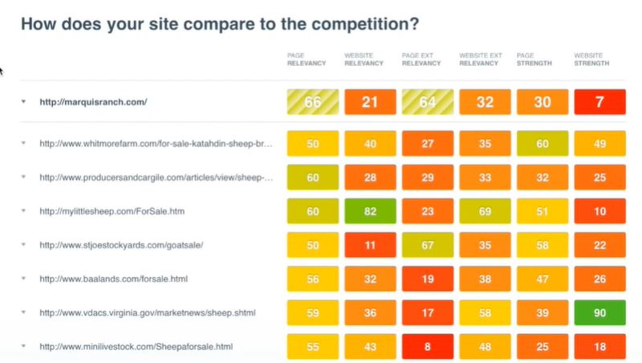

A Similar ranking system to my project.

I like the direct comparison to competitors.

#### General

CanIRank describes themselves as an SEO software AI to give you *“specific action recommendations rather than just data.”* (CanIRank, n.d.) CanIRank offer many different tools to assist people trying to improve their SEO, one of these tools is the competitor analysis tool show in *figure 1.*

One of the most obvious similarities between my solution and this tool is the “page relevancy” column which compares the user’s webpage to competitors based on lots of data that has been collected by CanIRank. This column is used to give the webpage a score out of 100 for how well the website will perform for a keyword the user wishes to look at. It does this by collecting thousands of different datapoints and presenting a summary in this table. (CanIRank, n.d.)

#### For My Project

What I like about this tool is how it shows the data breakdown for all the competitors, this would be useful for trying to outperform close neighbours in the search results. Although, this is a short-term approach since it focuses the user on one or two key websites which may change often, I believe that some form of comparison may be useful for the user, for example to make decisions about how they will outperform the competition.

### Ahrefs: Rank Tracking

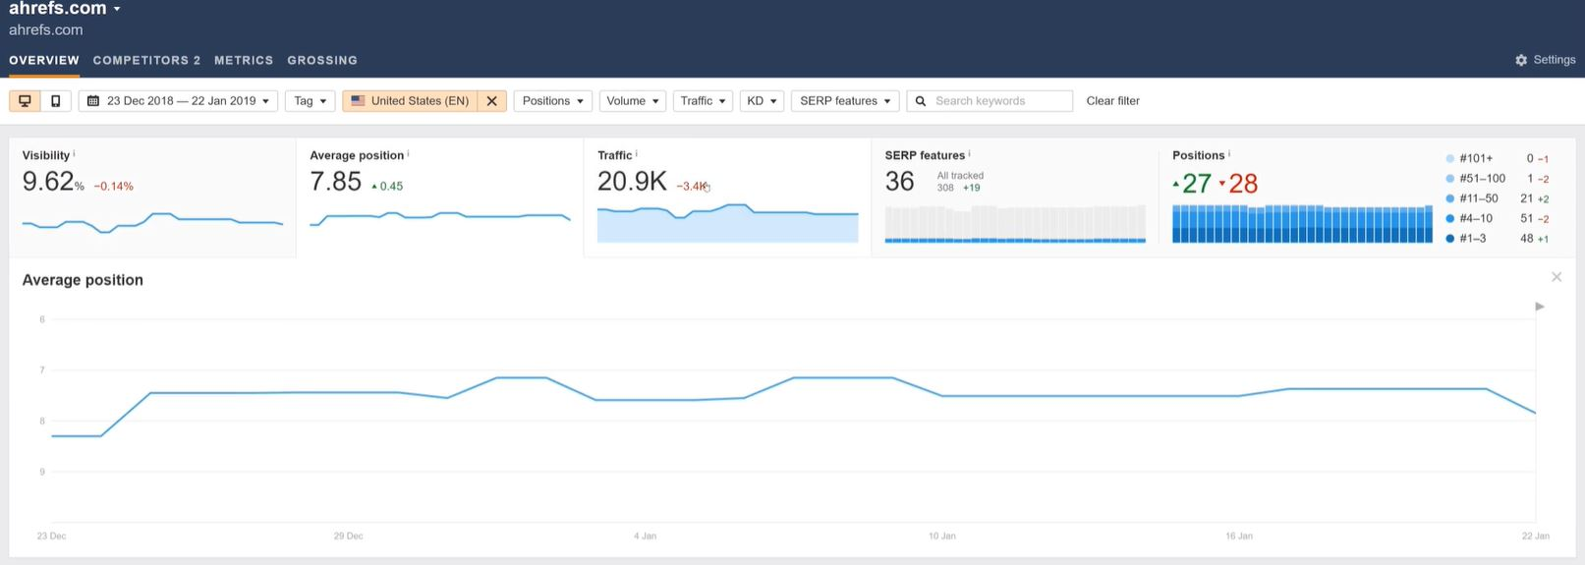

Useful visual data representation.

Lots of historical data.

#### General

Ahrefs is another SEO tool set which makes use of large amounts of data. One specific tool similar to my project is the Rank Tracing tool which traces how your webpage has performed for your keywords over time to see if progress is being made. Not only does it compare your position in search results, but also your website traffic and both absolute position and average position.

#### For My Project

One of the distinguishing features of Ahrefs’ rank tracing is the quantity of data specific to the user. I do think that personalized data such as ranking positions is useful, so I will involve a certain amount of personalized and historical data. However, purely focusing my project on historical data would not solve the problem I have identified; It would need to be incorporated with future predictions or be used to help the user with their SEO.

Another part of this tool I enjoyed was the visual data representation. I will try to incorporate visual elements to my project rather than simply showing the numbers.

### Pro Rank Tracker

Ability to input the search term to see if your website ranks for more obscure keywords.

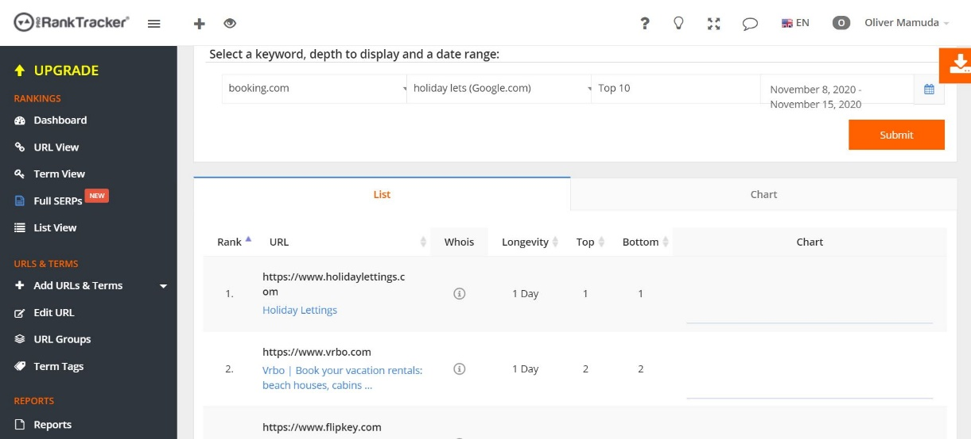

Embedded SERP, useful for keeping track of competitors.

#### General

Pro Rank Tracker is system used to rank websites based on their keywords, it can also compare websites rankings in googles search engine results page (SERP).

#### For My Project

I think including an embedded SERP would be useful for the users since it will allow them to see how often the rankings change (volatility) and they can compare themselves to competitors to get ideas for how to change their SEO strategy.

### Interviews

#### Rekha

1. **Which of the above solutions did you like the best? Why?**

*Pro Rank Tracker, since it pinpoints the keywords that successful businesses use to rank highly.*

1. **Which of the above solutions did you dislike the most? Why?**

*CanIRank since it was just data and you have to analyze it yourself.*

1. **If you could add more features that were not in these solutions, what would they be? Why?**

*The popularity of the words that clients are typing into their search engines.*

1. **Do you currently have an SEO Strategy? Why/Why Not?**

*No since I do not have the time at the moment.*

1. **Do you think business owners in holiday lets would benefit from my solution? Why/why not?**

*Yes, because it gives the information fast and shows the impact that these changes make to your outreach quickly.*

#### John

1. **Which of the above solutions did you like the best? Why?**

*Personally, I preferred Ahrefs because it had the most intuitive interface, and it gave me personalized data about my website which I found to be most useful.*

1. **Which of the above solutions did you dislike the most? Why?**

*If I had to pick, I would say CanIRank because it gave lots of data, but I wasn’t sure what it meant so really it was quite frustrating.*

1. **If you could add more features that were not in these solutions, what would they be? Why?**

*I think if there was a section where it told you how to use the software, or what the statistics meant then that would be helpful because I felt these tools were made for professionals rather than the average person.*

1. **Do you currently have an SEO Strategy? Why/Why Not?**

*No, because I am relatively new to websites and honestly, I do not have much spare time.*

1. **Do you think startup owners in holiday lets would benefit from my solution? Why/why not?**

*Yes, I think they would, especially the more online based ones because there is lots of competition.*

#### Emily

1. **Which of the above solutions did you like the best? Why?**

*I really enjoyed Pro Rank Tracker because it had a built-in search engine results page, so I was able to see what the user sees and adjust my SEO strategy accordingly.*

1. **Which of the above solutions did you dislike the most? Why?**

*Ahrefs because it lacked guidance. Although data can be useful, I do not think its effective on its own.*

1. **If you could add more features that were not in these solutions, what would they be? Why?**

*Personally, I would add a feature whereby it is easy to add multiple websites without multiple accounts.*

1. **Do you currently have an SEO Strategy? Why/Why Not?**

*Yes, since SEO is necessary for my job*

* 1. **If yes, can you describe it?**

*It varies from site to site, but the most common strategy for me it to find keywords that have low competition and a high search rate and try to rank for them, usually through using synonyms in the webpage content and title. The main ones I focus on are short term lets, holiday lets, short term accommodation and holiday accommodation.*

* 1. **do you think it is optimal or not?**

*It works well for me currently, but it could always be improved.*

1. **Do you think Online Presence Managers in holiday lets would benefit from my solution? Why/why not?**

*I would say most likely, however there are many SEO tools to choose from so it may be competitive.*

#### Muhammad

1. **Which of the above solutions did you like the best? Why?**

*Ahrefs because it was not too technical and showed the important information graphically, on a home page.*

1. **Which of the above solutions did you dislike the most? Why?**

*Both CanIRank and Pro Rank Tracker where frustrating for someone who does not know the technicalities of websites.*

1. **If you could add more features that were not in these solutions, what would they be? Why?**

*I am not sure, I think Ahrefs had the majority of what I was looking for.*

1. **Do you think business owners in holiday lets would benefit from my solution? Why/why not?**

*Certainly, as long as it is kept simple.*

#### Interview Analysis

The general views of my stakeholders are that the best solution is one that has a lot of functionality but is still easy to use. Another important aspect of a good solution is that it gives guidance in words rather than just data and numbers, so I will attempt to implement these into my own solution. The general views on what to avoid would be a solution that does not explain what the data being shown represents, therefore I will try to include explanations of how to use my solution when it is built. Additional features that my stakeholders found useful includes,

1. An embedded search engine results page
2. Graphical information
3. Personalized data
4. Historical data

## Essential Features

The following features are the aspects of my solution which I consider essential to solving the problem I have outlined.

Firstly, I will need to produce a dataset of information about different short-term lets related website and where they rank, I believe this is essential because of the research I did into ‘CanIRank’ where I found that a comparison with competitors is an important feature in order to see how well your website is ranking in the cohort.

Secondly, I believe a feature which quickly gives the user a clear and obvious prediction of where the website will rank in the future is essential, this is because of my interview with Rekha (question 5) where she mentioned that speed was important as well as John’s answer (question 3) where he mentions that the data should not be too complicated and instead intuitive.

I also believe an embedded search engine results page is essential due to my research into pro rank tracker where I identified the embedded search engine as a useful feature, additionally Emilie’s interview (question 1) identified an embedded search engine as useful.

Lastly, I think each person should their own account, and each account should have the ability to have more than one webpage linked to it. I believe this is essential because my interview with John (Question 1) Identified personalized data as important and Emily (question 3) stated having more than one webpage on one account as important.

## Hardware and Software Requirements

### For Me

**The TensorFlow library,** I plan to use this library in order to use code reuse which can save me a significant amount of time for machine learning without taking away the core features or functionality. TensorFlow (TensorFlow, 2021) states that it is supported on the following 64-bit systems:

* Python 3.6-3.8
* Ubuntu 16.04 or later
* Windows 7 or later
* macOS 10.12.6 (Sierra) or later

other than the list above, TensorFlow will run on a standard computer.

Additionally, I will need **internet access** using a standard internet browser in order to host the backend of my website through a third party and to use an API to aid getting the information from URLs off a search engine (see essential features).

### For my Users

Since the front end will be a website, all that is required is a standard computer with internet connection an internet browser installed such as the following:

* Google Chrome
* Firefox
* Safari
* Internet Explorer / Edge

## Requirements

### Requirements Specification

|  |  |  |  |  |  |  |  |
| --- | --- | --- | --- | --- | --- | --- | --- |
| **Requirement** |  | **Requirement** | **Solves** | **Evidence** | **Justification** | **Success Criteria** | **Evidence of Completion** |
|  | **1.1** | A dataset | Nothing to use for training the neural network resulting in the prediction being arbitrary / not backed by data. | Pg. 3 (web scraping) | The need for data is justified since the users of my solution should be given predictions which are as accurate as possible and the most effective way to doing this is through comparing webpages to a large amount of data. | * Requirement to collect at least 100 records of data * With at least 10 fields for each. | * Screenshot of database displaying the 10 fields. * Screenshot of database displaying the 100 rows. |
| **1: Data Collection** | **1.2** | Processing the data | The data being hard / impossible for a neural network to learn from. |  | The data’s purpose is to train the neural network. For this data to be useful it must be pre-processed before it can be used for training. | * All rows of data with null values must be deleted. * All categorical data must be encoded to numbers. | * Screenshots of samples of records showing encoded categories without null values. |

|  |  |  |  |  |  |  |  |
| --- | --- | --- | --- | --- | --- | --- | --- |
| **Requirement** |  | **Requirement** | **Solves** | **Evidence** | **Justification** | **Success Criteria** | **Evidence of Completion** |
| **2: Machine Learning** | **2.1** | A trained neural network | Nothing to base predictions off. | Pg. 3 (Machine Learning) | Machine learning is required for creating predictions since ML can find more complex patterns in data than humans can, therefore making it more effective for classification problems such as this. | * A trained neural network model that can make predictions. | * Screenshot of prediction from a trained network. |

|  |  |  |  |  |  |  |  |
| --- | --- | --- | --- | --- | --- | --- | --- |
| **Requirement** |  | **Requirement** | **Solves** | **Evidence** | **Justification** | **Success Criteria** | **Evidence of Completion** |
|  | **3.1** | Predictive ranking for the keywords “short term lets”, “holiday lets”, “short term accommodation”, “holiday accommodation” quickly | Need for users to know how their webpage will rank. | Pg. 2 (Identifying the problem)  Pg. 8 (Emily Q4 (a) ) | The purpose of this solution is for users to be able to predict how their website will rank faster than the search engine ranks it. | * A way of showing the predicted ranking to the user. * The option to update the prediction in less than a minute. | * Screenshot of a predicted ranking. * Screenshot of a timer showing less than a minute which was used to time the ‘update’ option. |
| **3: Functionality** | **3.2** | An embedded search engine results page. | The need for users to find how their webpage currently ranks. | Pg. 8 (Emily Q1) | Users need to see how their webpage currently ranks so they can see if they need to improve their SEO. Additionally, an embedded SERP will allow my users to see what their users would see on a search engine. | * A search engine embedded into my webpage that allows users to perform a search. | * Screenshots of the embedded search engine. |
|  | **3.3** | Ability to have multiple webpages on one account. | The issue of users having to create multiple accounts for multiple webpages. | Pg. 8 (Emily Q3) | If it were not possible to have multiple webpages on one account, then users would have to create multiple accounts, which will lead to duplicate data and frustration for the user. | * Ability to add another webpage to one account. | * Screenshot of option to add another webpage to the account. |

|  |  |  |  |  |  |  |  |
| --- | --- | --- | --- | --- | --- | --- | --- |
| **Requirement** |  | **Requirement** | **Solves** | **Evidence** | **Justification** | **Success Criteria** | **Evidence of Completion** |
|  | **4.1** | A method for the user to create / login to an account. | A lack of personalized data. | Pg. 8 (John Q1) | In order for the software to be useful for any specific user, data must be personal to the user. In order for this personalized data to be kept safe, a login system is required | * A way of creating an account. * A way to login to an account. | * Screenshot of a create an account page. * Screenshot of a login page, followed by a screenshot of after logging in. |
| **4: User Interface** | **4.2** | A database storing login information that is connected to the websites backend. | Allowing the user to login multiple times. | Pg. 8 (John Q1) | In order to implement a login system, this login information needs to be stored in a database. | * A database that is linked to my websites backend that stores a User ID, Username, and password hash. | * A screenshot of the database with these fields |

# **Design**

## Decomposition

### Top-Down Design

My reason for breaking the problem down in this way is it highlights where most of the work will be done in the backend of the project rather than simply breaking down the functionality of the website. I also chose to break my problem down into the smallest tasks in the correct order, making the progression of the development simple to see.

## Flowchart overview

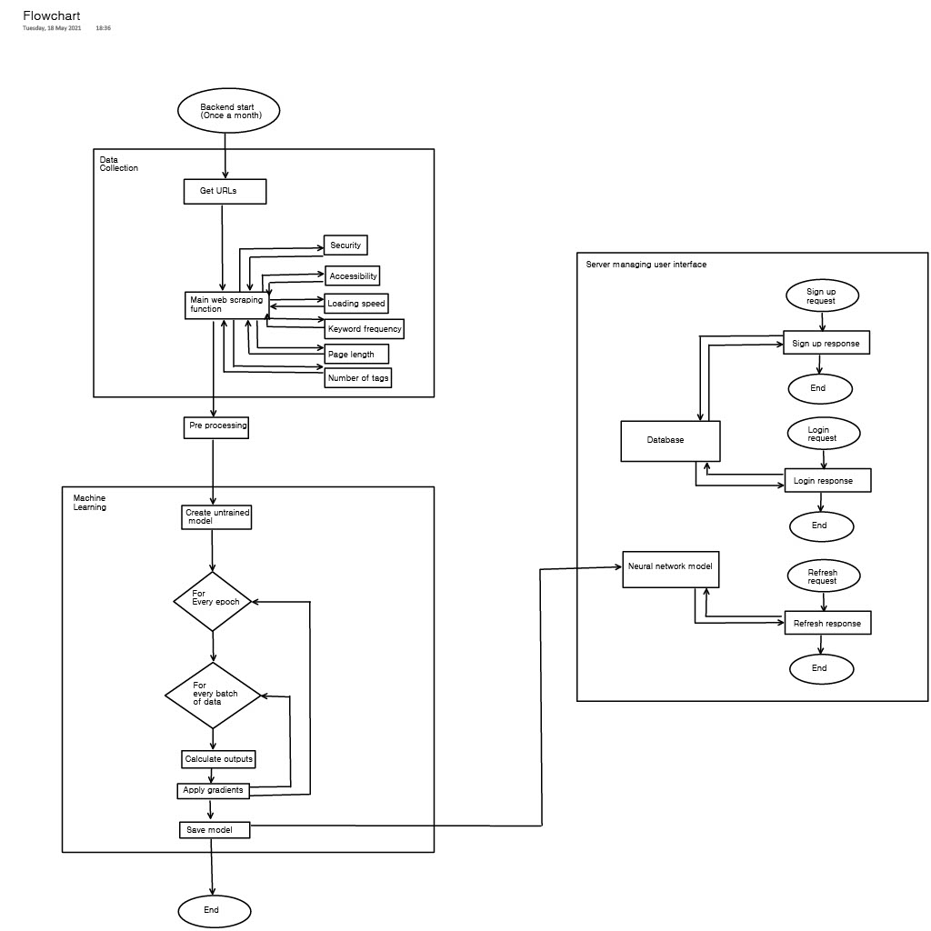

My justification for showing the flow of code in this way is that firstly, I believe the flowchart makes the solution clearer and easier to understand by showing which section each part of the flowchart belongs to, but it also includes lots of detail such as the most important loops and what initiates the start of each flowchart.

### Explanations and Justifications

#### Data Collection

My first algorithm will be used to collect the URL’s which I need for Web Scraping. Success criteria **1.1** requires that I produce a dataset that will be used to train the neural network, and the data I will be collecting is about the webpages that are ranked for “Short Term Lets”, “Holiday Lets”, “Short Term Accommodation” and “Holiday Accommodation” on a search engine because of the stakeholder Emily’s interview (Page 10, Question 5(a)) which suggested these keywords what this project should be using.

**Pseudocode**

The algorithm will firstly initiate the API to get the URLs from google with their rank position, it will then wait for this to finish before getting that URL data and returning it. My justification for having the algorithm work in this way is it makes use of code reuse from the API, as well as the fact that these procedures are clear and logically structured in order.

Function getURLs()

//initiates the API to get the URLs

urlToRun = googleWebScraper.createApiURL(

searchTerms=[”Short Term Lets”,

“Holiday Lets”,

“Short Term Accommodation”,

“Holiday Accommodation”],

numResults=500)

response = googleWebScraper.run(urlToRun)

print(response)

wait(600)

//gets the data it scraped

return googleWebScraper.getData(urlToRun)

End Function

My next algorithm will get the HTML accompanied by the first URL, this is the content of the webpage and therefore is required for collecting any data about a webpage, my algorithm will then search through the webpage for the following SEO indicators which are said to be “The Most Important SEO Ranking Factors” (Thompson, 2020).

1. The security of the website (by checking for the ‘s’ in https)

**Pseudocode**

This algorithm will firstly split the URL passed in as a parameter into everything before the colon and everything after it. E.g. “https” and “//google.com”. This first part (the protocol) will then be checked to see if it is “https” (and therefore encrypted and secure) or “http” (not secure) or a different protocol entirely in which case I will return -1 for this row to be deleted in preprocessing. My justification for this is that the webpages I will be dealing with will use hypertext transfer protocol, so for the data to be representational, I should exclude other protocols.

Function isSecure(url)

urlParts = url.split(“:”)

urlProtocol = urlParts[0]

if(urlProtocol == “https”)

return True

else if(urlProtocol == “http”)

return False

else

return -1

end if

End Function

1. The accessibility of the website (by checking for Whether the site’s robots.txt file has a “disallow: /”)

**Pseudocode**

Similarly, this algorithm compares the text of an accessible or inaccessible website. The robots.txt file is a file that is used to tell bots (such as googles crawler) whether the page is allowed to be crawled. If the page isn’t, then it is considered inaccessible (and therefore may rank lower on googles results page), otherwise it’s considered accessible, if the request was unsuccessful, then ‘-1’ is returned.

Function isRobotsCorrect(url)

urlParts = url.split(“/”)

robotsUrl = urlParts[0]+”//”+urlParts[2]+”/”+”robots.txt”

response = getRequest(robotsUrl, timeOut=25)

if(response.requestSuccessful == True)

lines = response.text.lower().split(“\n”)

if(lines[0] == “user-agent: *” && lines[1] == “disallow: /”)

return False

else

return True

end if

else

return -1

end if

End Function

1. Page loading speed

**Pseudocode**

this function gets the time, then makes the request, then gets the time again, the difference between these readings is the time take for one request, this is then repeated three time using a for loop and divided by 3 to get the mean. By justification for taking the mean is that one request will have a lot of random error (such as my Wi-Fi speed), an average should reduce this.

Function loadingSpeed(url)

for i=0 in 3

start = getTime()

response = getRequest(url)

end = getRequest(url)

totalTime = totalTime + (end - start)

end for

return totalTime/3

End Function

1. The number of key words in the <title> tags
2. The number of key words in the <h1> tags
3. The number of key words in the whole webpage

**Pseudocode**

This function achieves returning 3 indicators since the same html can be used for all three. Firstly, this html is requested, failed requests are handled. Then all text between title tags and h1 tags is received using regular expressions, these are then both passed onto a function which counts the number of keywords which is then returned. My justification for using regular expressions is, although regex cannot parse all possible HTML in a strict sense. For the majority of HTML written in a somewhat standard format regex will work to give a heuristic as an indicator (Cook, 2013).

Function numKeyWords(url)

response = getRequest(url)

//handles unsuccessful requests

if(response.requestSuccessful == False)

return -1

end if

html = response.text.lower()

//creates an array of every title/header tag

//(not including the tags themselves)

titles = html.listOfAllMatches(“<title.*?>(.*?)</title.*?>”)

headers = html.listOfAllMatches(“<h1.*?>(.*?)</h1.*?>”)

//for every title tag, all words in those tags are appended

for i=0 to titles.length()-1

titleWords.appendAll(titles[i].split(“ ”))

end for

//same for headers

for i=0 to headers.length()-1

headerWords.appendAll(headers[i].split(“ ”))

end for

//lastly counts the number of words in the body of the webpage

htmlWords = html.split(“ ”)

return (checkAgainstKeywords(titleWords), checkAgainstKeywords(headerWords),

checkAgainstKeywords(htmlWords))

End Function

**The Pseudocode for ‘checkAgainstKeywords’ (used above)**

This algorithm uses nested for loops to check every possible combination of keyword and word in array.

Function checkAgainstKeywords(arrToCheck)

keywords = [“short”, “term”, ”short-term”, ”lets”, ”let”,

“lettings”, ”holiday”, ”corporate”, ”rentals”, ”rental”, ”bnb”,

“bnbs”, ”accommodation”, ”medium-term”, ”medium”, ”serviced”,

“property”, ”properties”]

//checks every item of the array against every keyword using nested for loops

noMatches = 0

for i = 0 to arrToCheck.length()-1

for j = 0 to keywords.length()-1

if(arrToCheck[i] == keywords[j])

noMatches = noMatches + 1

end if

end for

end for

return noMatches

End Function

1. Length of the text in the <h1> tags
2. Length of the text in the whole webpage
3. Number of <a> tags (links)
4. Number of <video> tags (videos)
5. Number of <img /> tags (pictures)

These last indicators can be implemented using simple pattern matching (for 9, 10 and 11) and use of the length() function (for 7 and 8). Since they are not entire sub procedures by themselves and will subsequently be implemented in a different iteration, I do not believe they require pseudocode for explanation of how they will be included.

Once this data has been collected and stored, my algorithm will repeat this for all URLs on the list, on every loop a main web scraping function will call each of these subprograms to collect data on a certain aspect of the webpage. All of this is so I can have a full dataset in order to train the neural network later in the project. As is shown in the reference, each of these factors is correlated with highly ranked webpages and that is why I am using them for my project.

#### Data pre-processing

Next, I will make sure the data is suitable for the next stage, machine learning. By success criteria **1.2** I will process the data to make sure that the neural network can learn the correct patterns in the data. Firstly, I will be deleting files with null values because “no model can handle these NULL or NaN values on its own” (Kumar, 2018) and we do not want the model learning that null values have an effect.

Next, I will need to one-hot-encode any nominal categorical values such as security (Data Collection 1) and accessibility (Data Collection 2) because these variables can’t be ordered so in order for the model to be able to make use of this data, I will create columns which can be either 0 (not in this category) or 1 (in this category), (Kumar, 2018). For example, if the webpage is encrypted and secure, I will have a column called ‘secure’ where a 0 means it is not encrypted (http), and a 1 means it is encrypted (https).

Additionally, I will be normalizing data with different ranges because “practice has shown that when numeric x-data values are normalized, neural network training is often more efficient, which leads to a better predictor.” (McCaffrey, 2014). Since I need my neural network to make reasonable (accurate) predictions to achieve success criteria **2.1**, I will be normalizing my data.

When normalizing the two most popular options are as follows.

##### Shape Description automatically generated with medium confidenceMax-min normalization

*This image shows the formula for Max-min normalization* (Loukas, 2020)

The main advantages of a max-min normalization are that it restricts all data to between 1 and 0 and can be used for many different distributions, this makes it effective for machine learning since the range of all numerical data values are the same, resulting in no difference between the learning rate of different variables when training the dataset.

The main disadvantages of a max-min distribution are that it is heavily affected by anomalies which can skew the entire scaled distribution if not removed. Also, max-min normalization can skew the distribution if the range of values is unknown so that is why I will not be using max-min.

##### Chart, histogram Description automatically generatedGaussian Normalization

*This image shows the result of applying Gaussian normalization to a normal distribution.* (Bhandari, 2020)

The main advantages to using Gaussian normalization is that the distance a value is from mean is conserved, however the mean and standard deviation themselves become 0 and 1, resulting in a distribution that gives anomalies recognition without skewing the distribution.

The main disadvantages of Gaussian normalization are that if the distribution that is being normalized is heavily skewed, there will be more datapoints to one side of the normalized mean of 0, resulting in a decreased effect of normalization.

##### Conclusion

Due to the skewing that can occur when there is no obvious range of values and normalizing with max-min, alongside the benefit that anomalies do not have a major impact in Gaussian normalization, I will be choosing Gaussian normalization for the following numerical variables: Page loading speed (Data Collection 3); all key word numbers (Data Collection 4, 5, 6); all length of texts (Data Collection 7, 8); all numbers of html tags (Data Collection 9, 10, 11).

**Pseudocode**

This algorithm goes through every element in the 2d array using nested for loops (one for rows one for columns) and does the following:

* Delete the URL.
* If the element is -1 delete the row
* If the element is in a Boolean column and is true, set it to one (and zero for false)
* If the element is in a numerical column add its value to the total for the column

Then the necessary calculations are performed to standardize the arrays numerical data using these means. My justification for deleting null rows is that there is no way of handling nulls in a neural network, similarly, there is no way of handling Booleans, so they are one-hot-encoded. My justification for performing standardization can be seen above.

Function preProcess(dataset:byRef)

//predefines arrays storing the data needed for normalization

means = [0, 0, 0, 0, 0, 0, 0, 0, 0]

deviationSums = [0, 0, 0, 0, 0, 0, 0, 0, 0]

sdeviations = [0, 0, 0, 0, 0, 0, 0, 0, 0]

//looping through all elements with nested for loops

for i=0 to dataset.length()-1

//deletes the url for every row

delete(dataset[i][1]

for j = 0 to dataset[0].length()-1

currentVal = dataset[i][j]

//if the current value is a Boolean,

//replace true with 1 and false with 0

if(j == 1 || j == 2)

if(currentVal == True)

dataset[i][j] = 1

else if(currentVal == False)

dataset[i][j] = 0

end if

//if the current value is numerical,

//add it to ‘means’ for calculation later

else if(j > 2)

means[j-3] = means[j-3] + currentVal

end if

end for

end for

//divides by number of rows to get means

numRows = dataset.length()-1

for i = 0 to means.length()-1

means[i] = means[i]/numRows

end for

//CONTINUED

//CONTINUED

//loops through numerical data to find the deviations from these means

for i = 0 to dataset.length()

for j = 0 to dataset[0].length()-4

deviationSums[j] = deviationSums[j] + ((means[j] – dataset[i][j+3])**2)

end for

end for

//calculates final standard deviations

for i = 0 to deviationSums.length()

sdeviations[i] = squareRoot(deviationSums[i]/numRows)

end for

//standardization using $z= \frac{x- μ}{σ}$

for i = 0 to numRows

for j = 0 to dataset[0].length()-4

dataset[i][j+3] = (dataset[i][j+3] – means[j])/sdeviations[j]

end for

end for

saveArrayAsCSV(dataset, ‘/dataset.csv’)

Lastly, I will need to randomize the order of the data before splitting it training and testing data in order to remove bias, I will then be using the 80% training and 20% testing split which is recommended (w3schools, n.d.), however, since this dataset will be saved before being used and due to the fact that the data may be more useful for future development without this split and randomization, I believe this part of pre-preprocessing is best done in the machine learning section.

#### Machine Learning

Once the data is ready, I must create and train a machine learning model in order to meet success criteria **2.1**. The specific type of machine learning I am doing is called supervised machine learning which is the “use labelled data, which is a data set that has been classified, to infer a [learning algorithm](https://www.sciencedirect.com/topics/computer-science/learning-algorithm). The data set is used as the basis for predicting the classification of other unlabelled data through the use of machine learning algorithms.” (Talabis, 2015) . There are many factors that influence which algorithm to pick, so I will go through the most popular ML approaches and models to use.

##### Diagram Description automatically generatedA Decision Tree

A decision tree is a type of binary tree in which along every node is a conditional statement (decision) as whether the algorithm should traverse left or right, eventually leading it to a leaf node which will give the classification (w3schools, n.d.). The machine learning lies in the algorithm adjusting the conditions at each node to reach a tree that has the most accurate classifications.

The advantages of a binary tree are that it is possible to see how the function links the inputs to the outputs, and it is able to learn non-linear relationships (DTREG, n.d.), meaning decision trees can learn more complex relationships which is one of the aims of my algorithm.

However, decision trees have disadvantages, more specifically decision trees are not suitable for large datasets as they will usually lead to overfitting (which would make the actual accuracy of the model much lower than the accuracy on the training data, potentially not meeting success criteria **2.1**). Additionally, decision trees can be unstable and are largely affected by noise in the data (Kumar, 2019).

##### An Artificial Neural Network (Multilayer Perceptron)

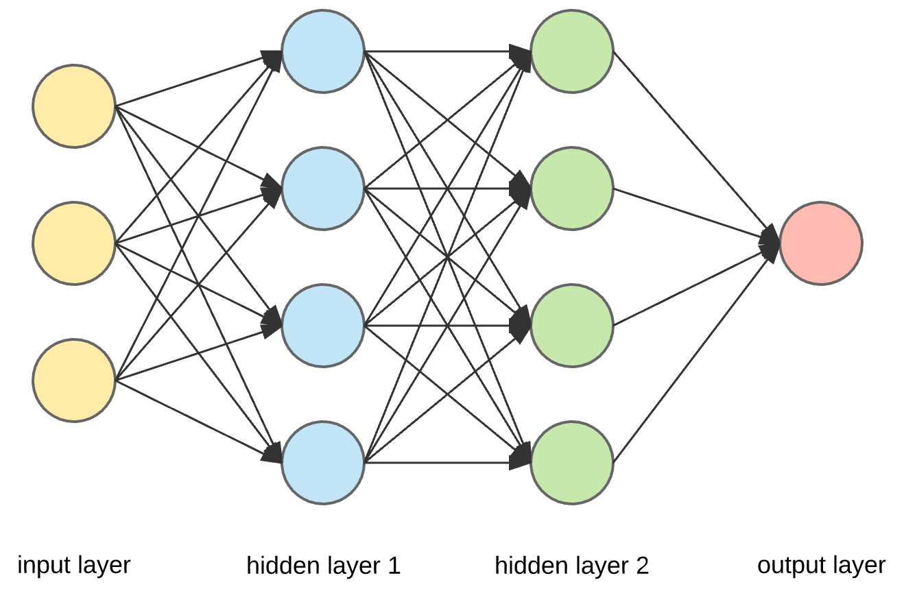An artificial neural network (or ANN) is a type of graph with weights between nodes which get multiplied by the previous node’s value; and biases which are added to the value at each node. Both of these can be adjusted by the ANN algorithm to link an input layer of nodes to the correct output (layer of nodes), this method of changing the parameters is called gradient descent.

The most significant advantage to ANN’s is their ability to learn complex, non-linear relationships similar to the decision tree however, ANN’s are known for working well with large datasets and they also have ways to stop problems like excess noise (such as batch learning) and overfitting (such as early stopping). (Dertat, 2017)

The obvious disadvantage to an ANN is that it operates like a black box with the layers between the input and output nodes being difficult to interpret (DTREG, n.d.) (which is where they get the name ‘hidden layers’). However, my project’s aim is to be able to test a webpages SEO so this should not be a problem.

##### Conclusion

After researching these two common approaches, I have decided to use an artificial neural network despite the fact that it works as a black box, because I believe it is more important that the algorithm can handle large amounts of data which the decision tree cannot.

#### Training

In order to train the model, I will need to feed one record of data into the input neurons (this will be the number of key terms, length of title …). The algorithm will then calculate the values in each of the neurons according to the activation function, the activation, the neuron’s weight, and bias.

There are many activation functions to choose from and the important factors to consider when choosing one are first, how easy it is to differentiate (this speeds up gradient decent) and also whether it is linear or not. Considering the options (Sharma, 2017), I have chosen the rectified linear activation function since it is nonlinear and easily differentiable.

Until the final output layer has been calculated, I can then find the gradients of the model and use them to adjust the weight and biases so that the model will make more accurate predictions the next time. I will then repeat this process on all the data collected multiple times (called epochs) until the cost is reasonably low (success criteria **2.1**).

This is a very low-level method of machine learning which is useful for when the cost needs to be lowered in later iterations, however since I can make use of code reuse through libraries by using a higher-level approach, this will be the first iteration.

**Pseudocode – creating the untrained model.**

This function intuitively adds new layers starting with the input, then 3 identical hidden layers followed by one outer layer. My justification for this function is it is required to have the model that will make the users predictions.

Function createModel()

//creates the neural network object

model = new neuralNetworkModel(activationFunction = relu)

//adds necessary layers

model.addLayer(input=True, output=False, numNodes=11)

for i = 0 to 3

model.addLayer(input=False, output=False, numNodes=15)

end for

model.addLayer(input=False, output=True, numNodes=1)

return model

End Function

**Pseudocode – Training**

Function trainModel(model, myFeatures, myLabels)

model.setLoss(“MSE”) //this calculates how ‘wrong’ each prediction is using

//the Mean Squared Error function

model.setOptimizer(“SGD”, learningRate=0.001) //the Stochastic Gradient…

//…Descent optimizer is the function that updates the model based on the gradients

model.setBatchSize(5)

model.train(epochs=200, features=myFeatures, labels=myLabels)

return model

End Funtion

#### User Interface

There are two ways I could have the user interact with my trained ANN, I could either make a website or a downloadable application. However, a downloadable application has many issues such as the fact that different computers have different architectures so I would have to compile multiple versions of my software. Due to this I will create a webpage that has the trained ANN linked to its backend.

My next issue is security, I do not want the data that the user inputs to be publicly available so I will have to create a secure login system. I will do this by implementing this order of events.

1. The user requests a login form.
2. The server sends a login form.
3. The user POST requests the submitted form.
4. The server hashes the received password and checks it against the stored hash in the SQL Database.
5. If they match, grant access, otherwise do not allow access.

It is important that passwords are not stored in plaintext as a compromised database could put many of their other applications at risk (Kumar, 2018).

**Pseudocode – server sending a login form.**

//if someone get requests the root folder, sendLoginPage will run

server.onGetRequest(“/”, sendLoginPage(request, response))

//returns the html file I’ve written to the user

Function sendLoginPage(request, response)

response.sendFile(“/login.html”)

End Function

**Pseudocode – server receiving a login form.**

Server.onPostRequest(“/loginForm”, validateLogin(request, response))

Function validateLogin(request, response)

//gets and sanitizes the user input

thisUsername = sanitize(request.username)

thisPasswordHash = hash(sanitize(request.password))

//gets the corresponding data from the table

dbPasswordHash = sqlConnection.query(“SELECT passwordHash

FROM users

WHERE username=thisUsername”)

//tests validity of user input

if((5 < thisUsername.length()-1) && (thisUsername.length()-1 < 15) && (5 < thisPasswordHash.length()-1) && (thisPasswordHash.length()-1 < 15))

//checks if username and password match

if(thisUsername == dbUsername && thisPasswordHash == dbPasswordHash)

//sends the personalized data for the user

userData = sqlConnection.query(“SELECT userData

FROM users

WHERE userID=thisUsername”)

response.send(userData)

else

response.send(-1)

end if

else

response.send(“invalid login”)

end if

End Function

**Pseudocode – server receiving a sign-up form.**

Server.onPostRequest(“/signUpForm”, validateLogin(request, response))

Function validateLogin(request, response)

//gets and sanitizes the user input

thisUsername = sanitize(request.username)

thisPasswordHash = hash(sanitize(request.password))

confirmPasswordHash = hash(sanitize(request.confirmPassword))

//checks if the username is taken

duplicates = sqlConnection.query(“SELECT username

FROM users

WHERE username=thisUsername”)

if(duplicates == null)

//checks if the password was confirmed correctly

if(thisPasswordHash == confirmPasswordHash)

//tests validity of user input

if((5 < thisUsername.length()-1) && (thisUsername.length()-1 < 15) && (5 < thisPasswordHash.length()-1) && (thisPasswordHash.length()-1 < 15)

//adds their data to the database

sqlConnection.query(“INSERT INTO users (username, password) VALUES (‘”+thisUsername+“’, ‘”+thisPasswordHash+“’)”)

response.send(“new account created”)

else

response.send(“invalid username/password”)

end if

else

response.send(“passwords do not match”)

end if

else

response.send(“username taken”)

end if

end function

## User Interface

### Graphical user interface, application Description automatically generatedLogin / Signup

A login/signup page is requirement **4.1** on my requirements specification. I chose to have dark text against light backgrounds to ensure accessibility for colorblind people (RNIB, 2015) and the submit buttons are large and clear to see to help those with visual disabilities.

### Predicted Rankings and SERP

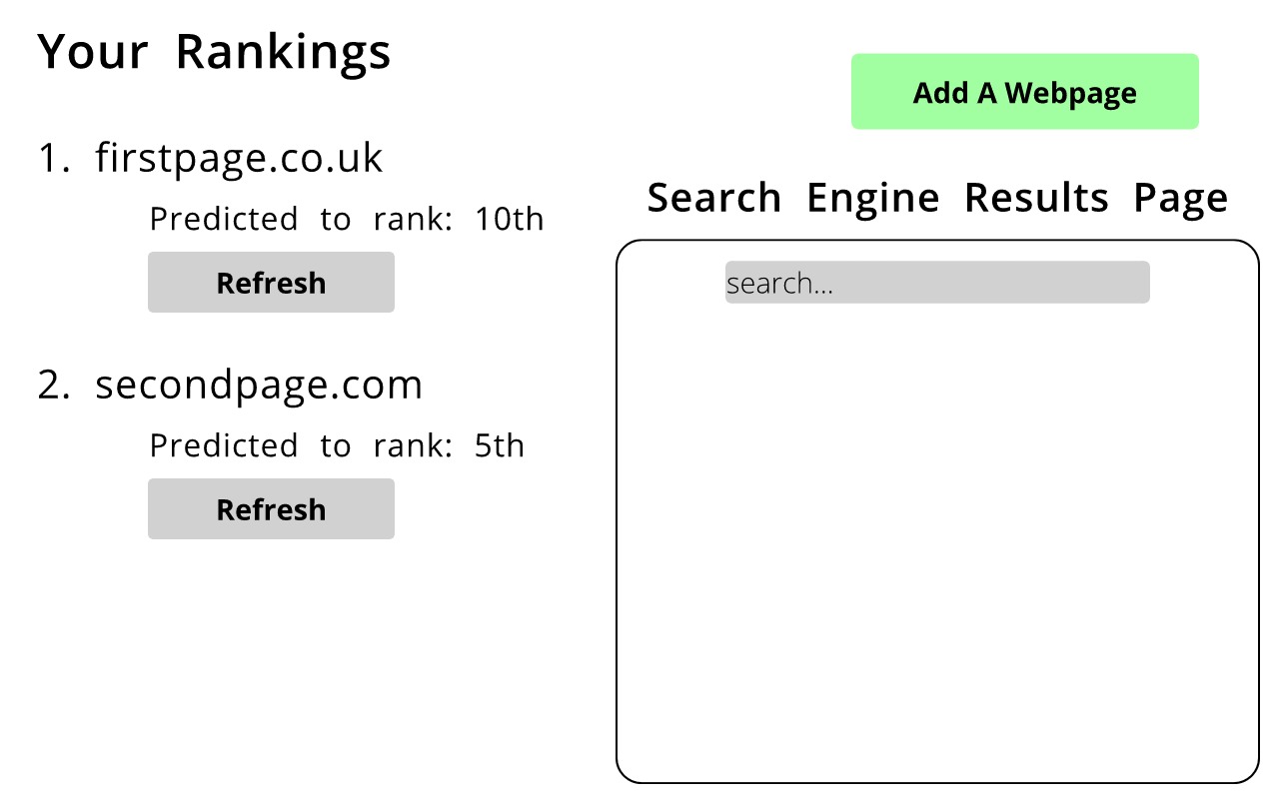

This home page design will satisfy success criteria **3.1**, **3.2** and **3.3** by having predicted rankings for, in this example case, the webpages ‘firstpage.co.uk’ and ‘secondpage.com’ as well as the ability to have many webpages through the use of the button at the top right and lastly an embedded search engine results page (SERP) on the right-hand side. My justification for including the ability to refresh the predicted rank is so that when adjustments are made to the website, improvements can be seen quickly which was identified as the purpose of my project in my ‘analysis’ section.

**Pseudocode – server: refresh button**

Server.onGetRequest(“/refresh”, refresh(request, response))

Function refresh(request, response)

if(authenticate(request.authentication))

//gets the website from the request

thisWebsite = request.website

//web scrapes the website

rawData = [isSecure(thisWebsite),

isRobotsCorrect(thisWebsite),

loadingSpeed(thisWebsite)]

.append(numKeyWords(thisWebsite))

//uses a function very similar to preProcess() to process the data

processed = processRawData(rawData)

if(processed == null)

response.send(“our requests failed”)

else

//imports the model and sends the prediction

model = importSavedModel(“/model”)

prediction = model(processed)

response.send(prediction)

end if

else

response.send(-1)

end if

End Function

## Usability and Accessibility

The majority of accessibility features will be in the ‘User Interface’ section outlined in my top-down design since that is where the users interact with the website. As specified earlier, here are the ways in which my project will be easily usable as well as accessible to the disabled:

|  |  |
| --- | --- |
| **Feature** | **Purpose** |
| Black text on light backgrounds. | To help colorblind people since it is a safe color combination, as well as to avoid similar colors in the text and background, making the page hard to read. |
| Large, easy to locate buttons. | To help those who do not have precise mouse movements and to make it clear where on the page to click. |
| Large, easy to locate text fields. | To help those who do not have precise mouse movements and to make it clear where on the page to type. |
| Some light green buttons | These signify the important buttons that must be pressed for the use of the program and will help make clear which buttons these are. |

## Key Variables and Data Structures

### Data Collection

|  |  |  |  |
| --- | --- | --- | --- |
| **Variable Name** | **Datatype** | **Where its used** | **How it is used** |
| urlToRun | String | getURLs() | It stores the URL that needs to be POST requested in order for Apify to start running my actor that gets the URLs from google. |
| items | 1D Array of Strings | getURLs() | Stores the XML in string format for every page (as they appear on google). Called items since this is the XML tag used by Apify for every page. |
| urlData | 2D List | webScrape() | It stores the data (before pre-processing) that will be used to train the neural network. It is populated with data about the URLs from google such as their position, security, number of keywords, etc. (see page ‘Explanations and Justifications’ for’ Data Collection’) |
| urlProtocol | String | isSecure() | Stores the slice of a URL to the left of the colon (the protocol). |
| lines | 1D Array of Strings | isRobotsCorrect() | Stores every line of the robots.txt file that the website has in an element of this array. |
| totalTime | float | loadingSpeed() | Stores the amount of time it takes for three requests to be responded to for a URL. |
| htmlWords | 1D array of Strings | numKeyWords() | Stores every block of text separated by spaces in the html document, or words (not including between script tags, etc.) |
| noMatches | Integer | checkAgainstKeywords() | Stores the number of words that match my list of keywords. |
| noTags | 1D Array of Integers | numKeyWords() | Stores the number of tags in this format [links, videos, images] for one html document. |
| means | 1D array of floats | PreProcess() | Initially stores the sum of all values in numerical columns (e.g. the first element is the sum of the loading speeds), each of which is then divided by the number of rows to get the means. |
| csvWriter | A writer object | writeToCSV() | The writer object is what is actually responsible for writing the ‘data’ variable to the csv file. |
| model | TensorFlow model object | createModel() | The model is a weighted graph data structure that connects the inputs (features) to the outputs (labels). See ‘An Artificial Neural Network (Multilayer Perceptron)’ on page 16 for more details. |

## Testing

Here I will outline what subroutines need to be tested and for what. The second column specifies a subroutine when implemented on the backend and an area on the website when implemented on the front-end.

|  |  |  |
| --- | --- | --- |
| **ID** | **Subroutine / Area of Website** | **Test** |
| 1 | getURLs | That the subroutine outputs the URLs correctly for the correct web scraping terms (criteria **1.1**). |
| 2 | isSecure | Whether the subroutine outputs the correct Boolean for secure and insecure websites (criteria **1.1**). |
| 3 | isRobotsCorrect | Whether the subroutine outputs the correct Boolean for websites with correct robots and websites with incorrect robots (criteria **1.1**). |
| 4 | numKeyWords | That the number of keywords counted is correct for websites with and without my specified keywords (criteria **1.1**). |
| 5 | findTags | That the correct number of tags were returned for different websites (criteria **1.1**). |
| 6 | preProcess | That the subroutine returns data correctly normalized and encoded (criteria **1.2**). |
| 7 | writeToCSV | That, when called, a csv file is create with the correct name, data and metadata (criteria **1.1**). |
| 9 | importData | That, when called, the data from the specified csv file is returned (criteria **2.1**). |
| 10 | createModel | That, when called, a MLP model is created with random parameters (weights and biases of the graph), (criteria **2.1**). |
| 11 | trainModel | That the returned model is better than the initial model at predicting a URL position, (criteria **2.1**). |
| 12 | exportModel | That, when called, a file is created with the correct name storing the optimized model, (criteria **2.1**). |
| 13 | importModel | That, when called, returns the specified model from its file, (criteria **3.1**). |
| 14 | Login / sign up page | That a get request to my login page (hosted on localhost) shows the login page, (criteria **4.1**). |
| 15 | Login / sign up page | That a user can create an account successfully with my login page, unless a field is left blank in which case, they will be prompted to re-enter, (criteria **4.1**). |
| 16 | Login / sign up page | That a user can login successfully to their account with my login page, unless a field is left blank in which case, they will be prompted to re-enter, (criteria **4.1**). |
| 17 | Predicted rankings and SERP | That the top right “Add a webpage” button will reveal a form that can be filled out to show a webpage (to the left of the screen), and if filled out with an invalid URL, will ask the user to submit another, (criteria **3.2**). |
| 18 | Predicted rankings and SERP | That the “Refresh” button updates the ranking within one minute (criteria **3.1**) |
| 19 | Database | That when an account is created, the data is inputted correctly to the database, (criteria **4.2**). |

### Post Development Testing

For reference in my evaluation, my post-development test plan will use black box testing by my stakeholders, each stakeholder will first have to follow these scenarios and give feedback before using the system for themselves and giving feedback:

**Scenario 1**

1. Login the following account:

Username: jsmith123

Password: MyNameIsJohn

1. Add the following webpages:

<https://airbnb.co.uk/>

<http://example.com/>

1. Refresh each of the rankings and find out what each is predicted to rank.
2. (within the webpage) find out what position booking.com is on the search results page for “accommodation”.
3. Log out.

**Scenario 2**

1. Create the following account:

Username: Foobar

Password: foofoobbarbar1000

1. Add the following webpage:

google.com

1. Refresh the ranking.
2. (within the webpage) find out if the website “haven.com” is on the search engine.
3. Log out

# **Implementation**

## Data Collection

### Getting the URLs

|  |  |
| --- | --- |
| **Inputs** | **Outputs** |
| The search query | A list of the form:  [[1, ‘https://firstURL/’], [2, ‘http://second/’], …] |

The first algorithm of this project to be implemented is a method of getting the URLs that appear on Google’s search engine results page (this can be seen in my top-down design). To do this I will be using an Apify’s API which I have set up as such that to get the URLs, I need to POST request this URL (with my private token):

[https://api.apify.com/v2/actor-tasks/BAf5zwoJRw3xh02CW/runs?token=[I-will-put-my-token-here]](https://api.apify.com/v2/actor-tasks/BAf5zwoJRw3xh02CW/runs?token=%5bI-will-put-my-token-here%5d)

and to get the data from my most recent request in an XML format, I need to GET request the following (again with my private token):

[https://api.apify.com/v2/actor-tasks/BAf5zwoJRw3xh02CW/runs/last/dataset/items?token=[I-will-put-my-token-here]&format=xml](https://api.apify.com/v2/actor-tasks/BAf5zwoJRw3xh02CW/runs/last/dataset/items?token=%5bI-will-put-my-token-here%5d&format=xml)

Here is the input in JSON format that this API needs to get the URLs:

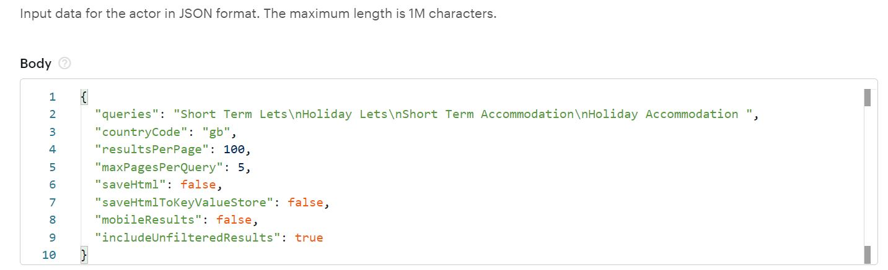

In order to make these GET and POST requests, I will use pythons ‘requests’ module and in order for my program to wait for the request to finish before accessing the data I will use pythons ‘time’ module. Looking at the XML outputted from one of these requests below, it is clear that I will need to divide the XML into an array of pages and calculate the URLs position from the page number and number of URLs down that page.

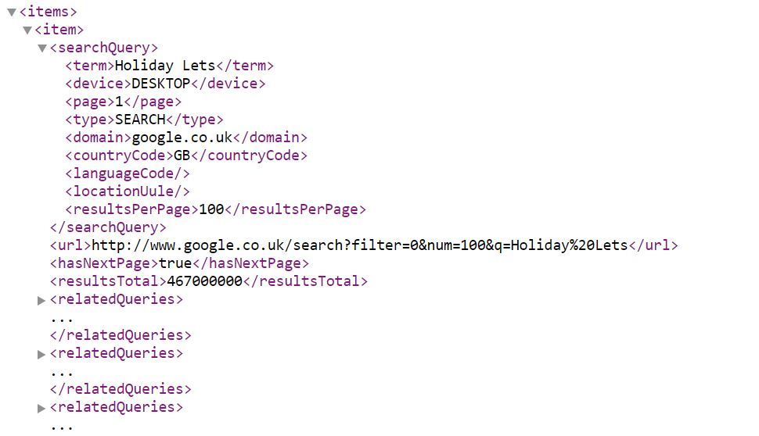This shows page 1 (on the first <item> tag)

These are the URLs I need

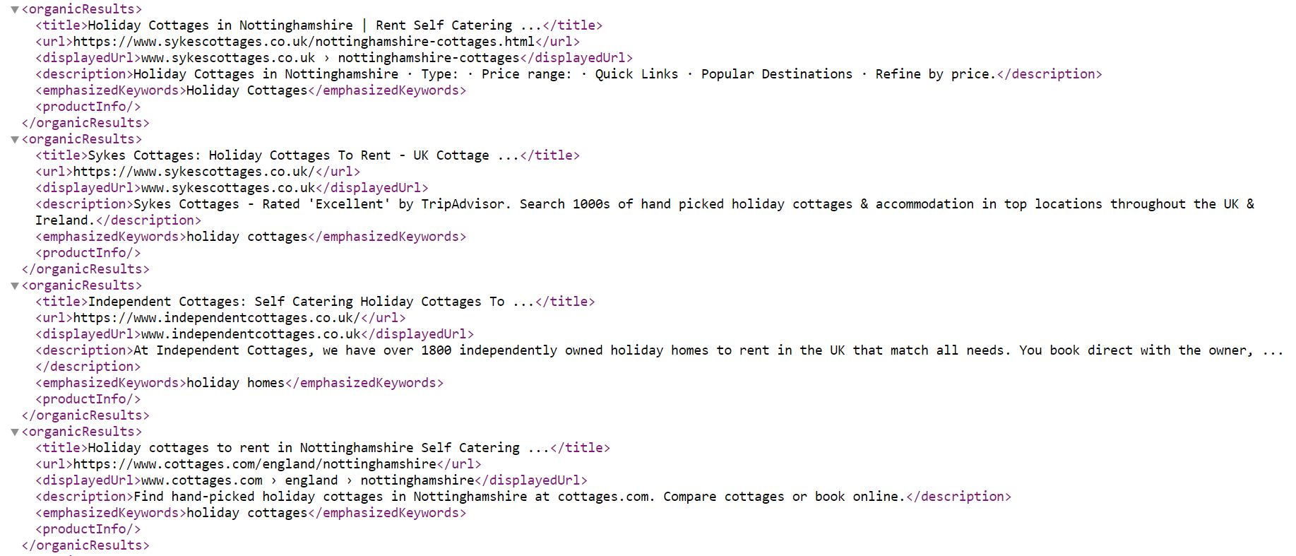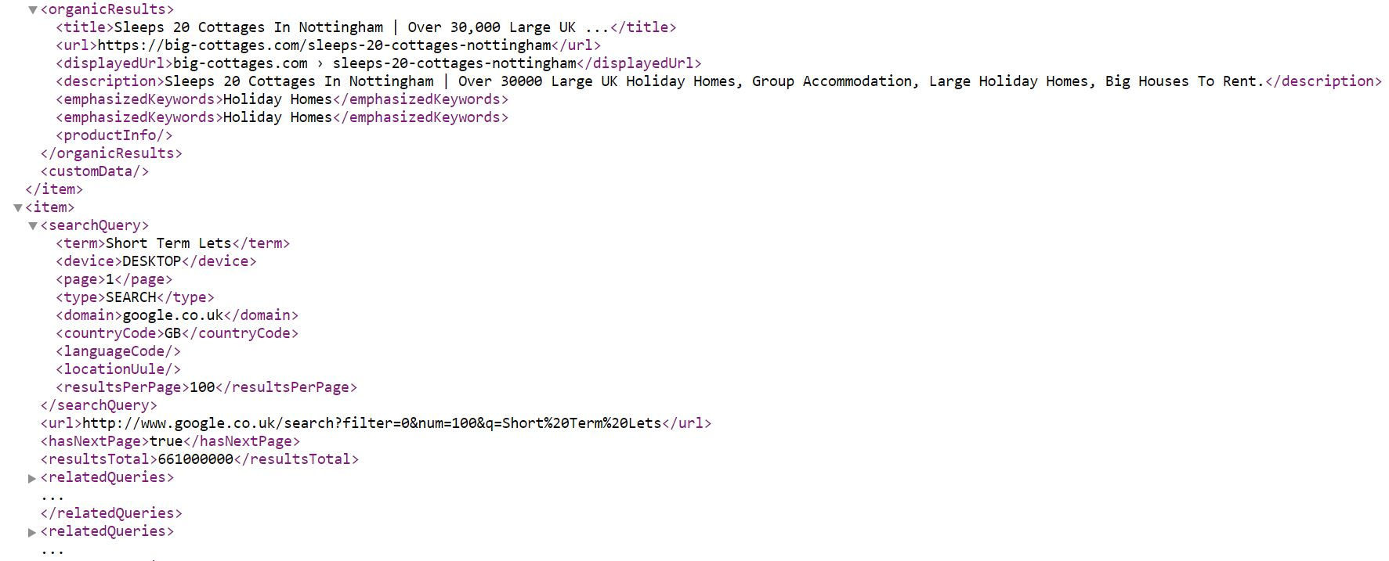

This is the next <item> tag but with a different search term.

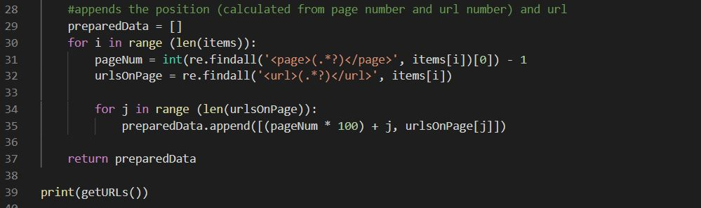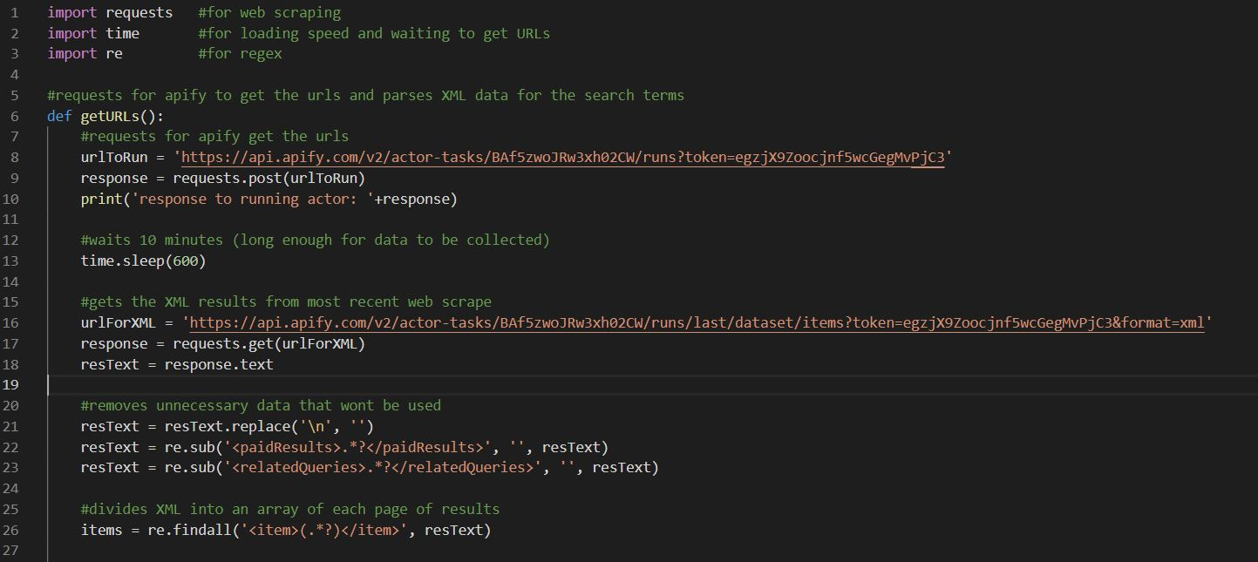Here is my first attempt at implementing this:

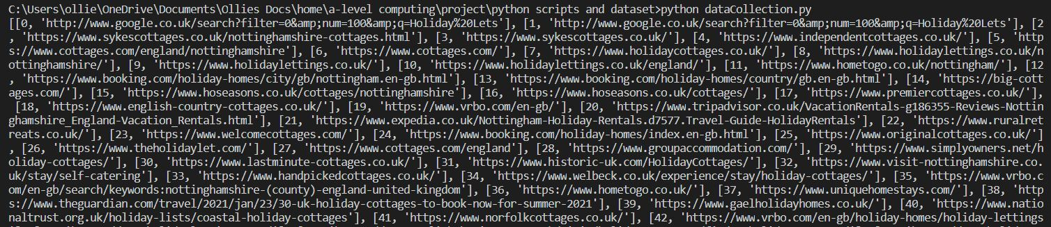In order to make testing more efficient, I will comment out lines 7-13 which I can test afterwards. This some of the output:

Looking at this, you can see the first URL is a google one which should not be the case. The problem here is that my program currently takes all URLs on the page, including the first URL stating the google search. Additionally, on line 35 you can see how I calculated the URL position using the loop counter ‘j’, however this starts at zero which would teach my neural network to classify URLs starting from zero which does not make sense.

To fix these issues, first I checked whether the URLs where inside a <organicResults> tag. Secondly, instead of using ‘j’ on line 35 I used (j+1).

Here is the code with the corrections:

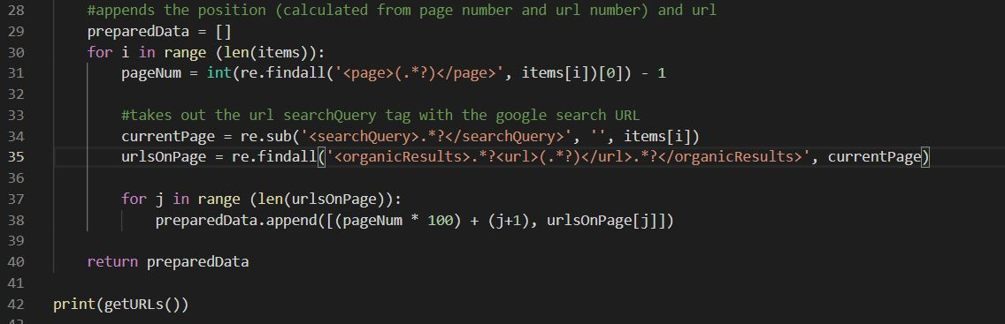

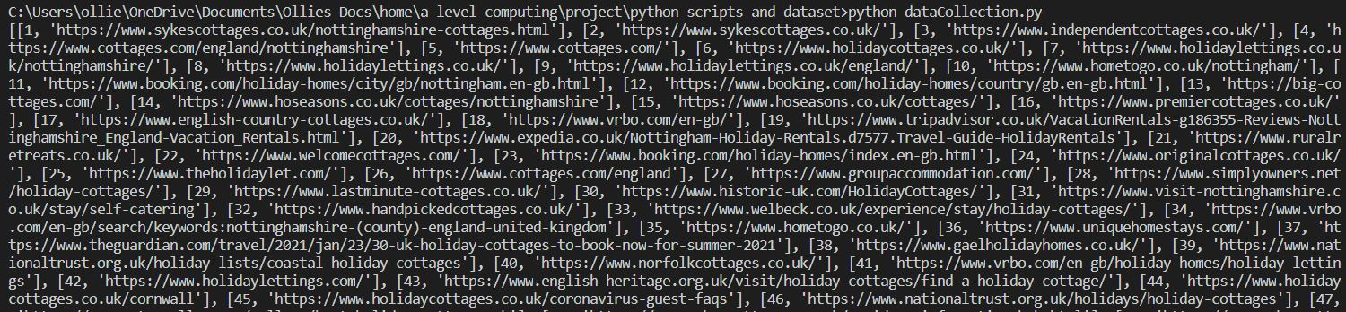And the new output:

Here, the output is as expected.

Before testing with the first section not commented out, I noticed line 10 was going to print the response rather than the body text, so I changed this to concatenate ‘response.text’. This worked correctly, outputting:

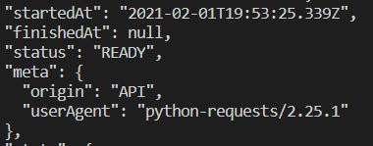(this was only a section of the response; however the rest was confirming my private tokens which I considered irrelevant)

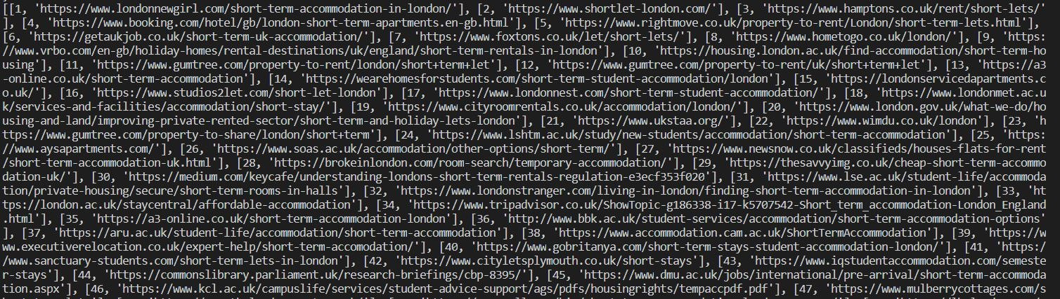

These URLs, correctly different from the previous which was web scraped earlier, are as expected.

### Web Scraping: Checking Security

|  |  |
| --- | --- |
| **Inputs** | **Outputs** |
| URL in string format | A security Boolean |

As mentioned in design, I will be checking the security of the website by looking for the ‘s’ in https at the start of a URL, this check will be done in its own function which is called by the main Web Scraping function.

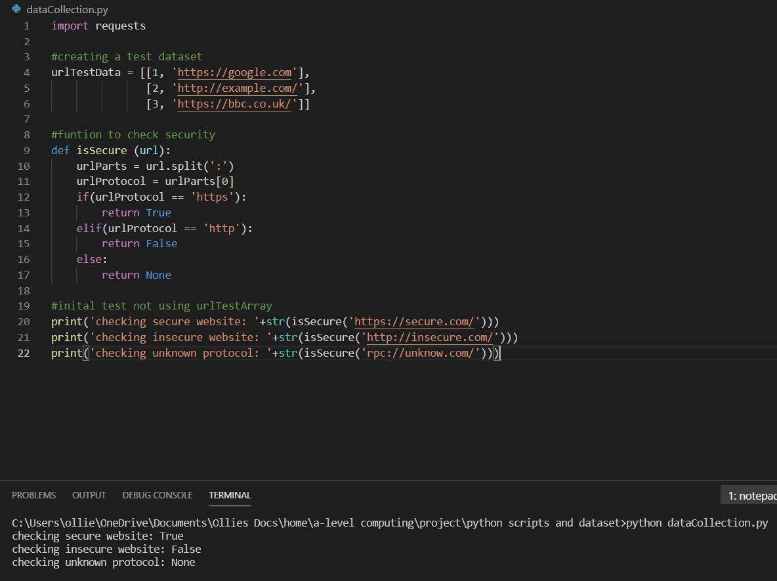

The way this works is by splitting the URL at the colon leaving, for the example below:

<https://secure-website.co.uk/> as [‘https’, ‘//secure-website.co.uk/’]. The first item in this array is the protocol being used, so I checked whether the protocol was https (meaning encrypted) or http (not encrypted) or something else which I left as null. As can be seen on the testing, this function works for all protocols.

Combining this with a main Web Scraping function resulted in.

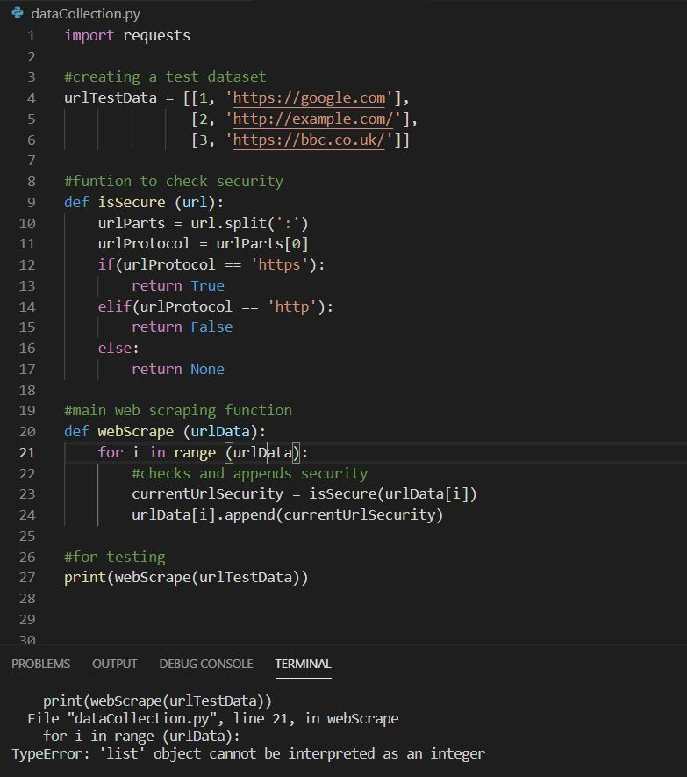The way I wanted this to work was by using a FOR loop to go through every row of the 2D array ‘urlData’ and append a Boolean for the security of the website, however it returned null.

I identified 3 mistakes here, one was that I forgot to return the 2D array under line 24, the second was that my FOR loop (line 21) does not have an integer number of times to run, I accidently passed in a list. Lastly, I passed a list as the parameter for ‘isSecure’ (line 23) whereas the second element was all that was needed.

I then fixed the mistakes.

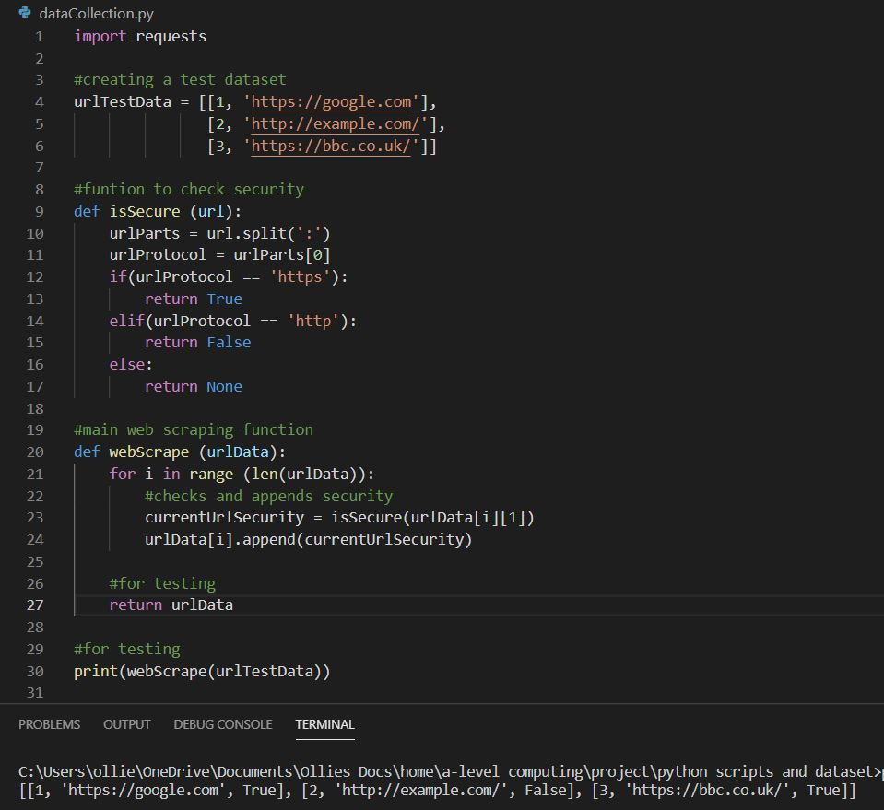This yielded the correct results.

### Web Scraping: Checking Accessibility

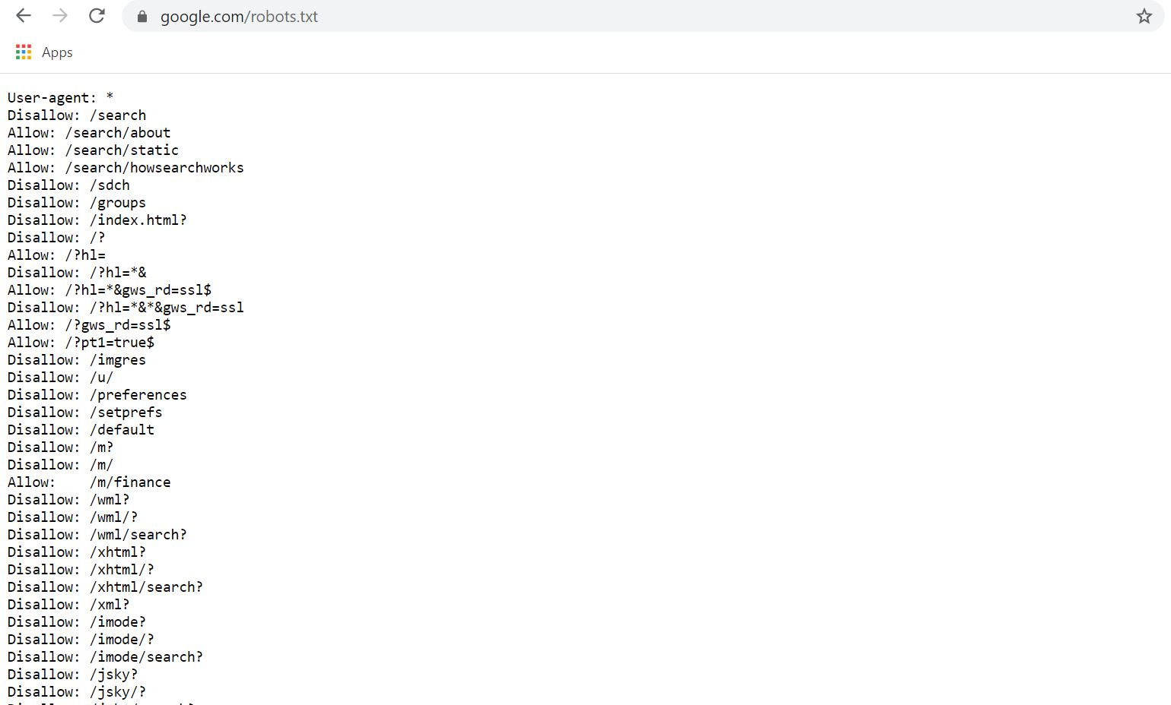The next function to be written will access a file called the ‘robots.txt’ file that websites have so search engines can see if the user wants the webpage to be crawled. I will check this by splitting the URL at the forward slashes and combining them such that it gives the robots.txt location.

Here is an example of Googles robots.txt file, It says that all bots (for example the crawlers that find websites for bing, indicated by ‘user-agent: *’) are not allowed to crawl, for example <https://google.com/search/> or <https://www.google.com/sdch/> . The unhealthy robots.txt files are ones where its set by default to disallow all, so that is what I will check for:

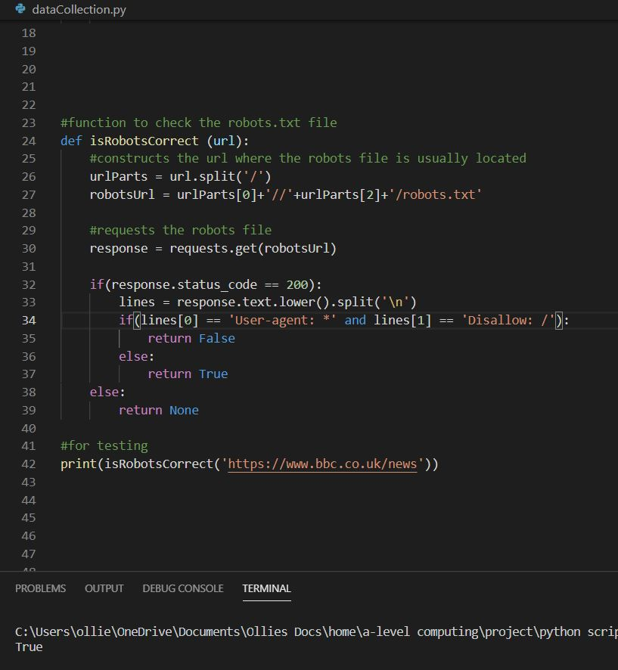Testing on a correctly initiated robots file gave the correct results. Since I am unable to find a website with a disallow all robots file, I will replace lines with the lines of an incorrect robots file.

The results can be seen below:

This incorrectly return True when it should have been False, the error here was that my IF statement (line 34) was looking for lines with capital letters inside it, when I had converted all lines to lower case in line 33.

Fixing this gave:

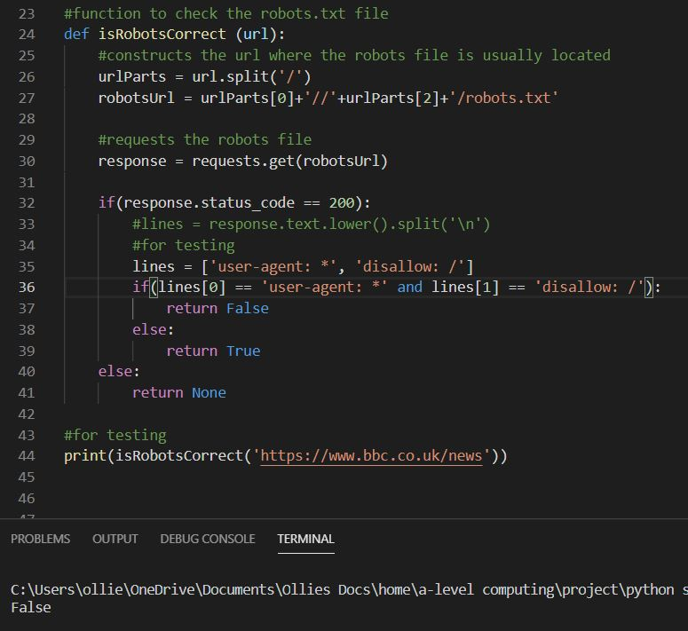

Which was the correct outcome.

Now removing the testing data and implementing this with the main web scraping function resulted in:

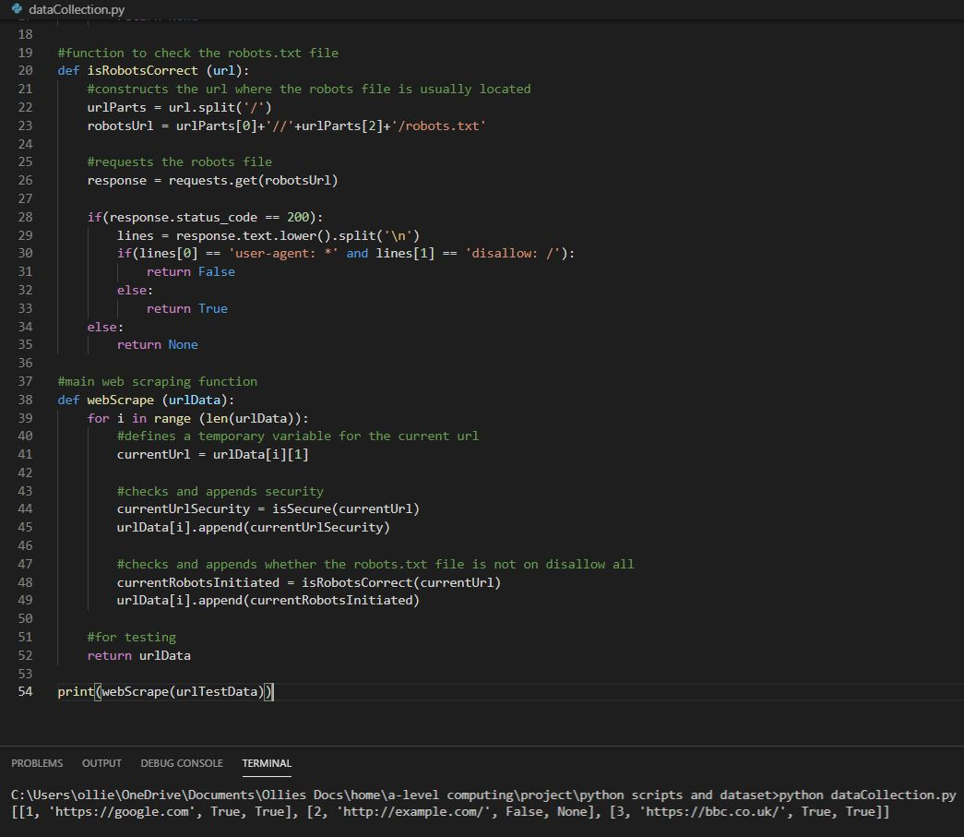

Which returned the correct results.

### Web Scraping: Loading Speed

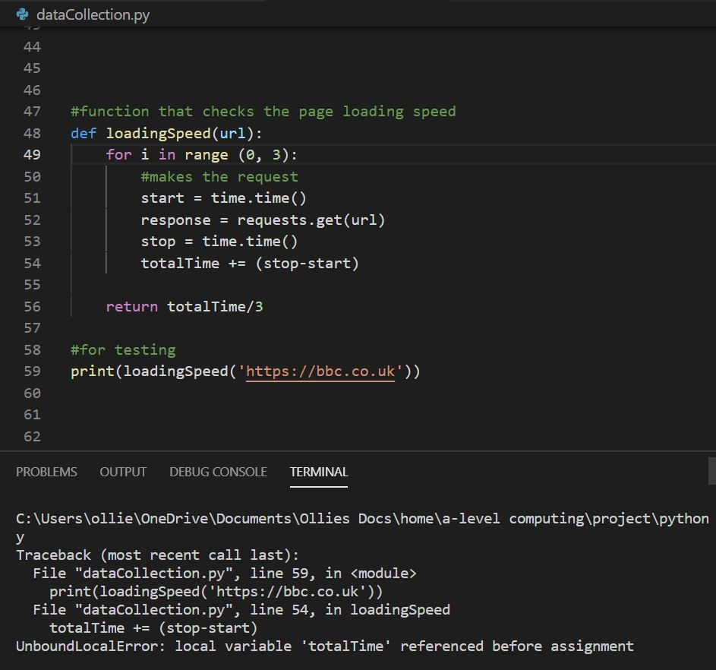In order to get the loading speed of the web page, I will get the time in seconds immediately before and after requesting the URL. In order to make the results more precise, I will do this three times using a FOR loop and divide by 3 to get the average:

The error here is that I did not predefine the variable ‘totalTime’ which I use to calculate the total time taken for three requests. Predefining this to be zero returned the right result:

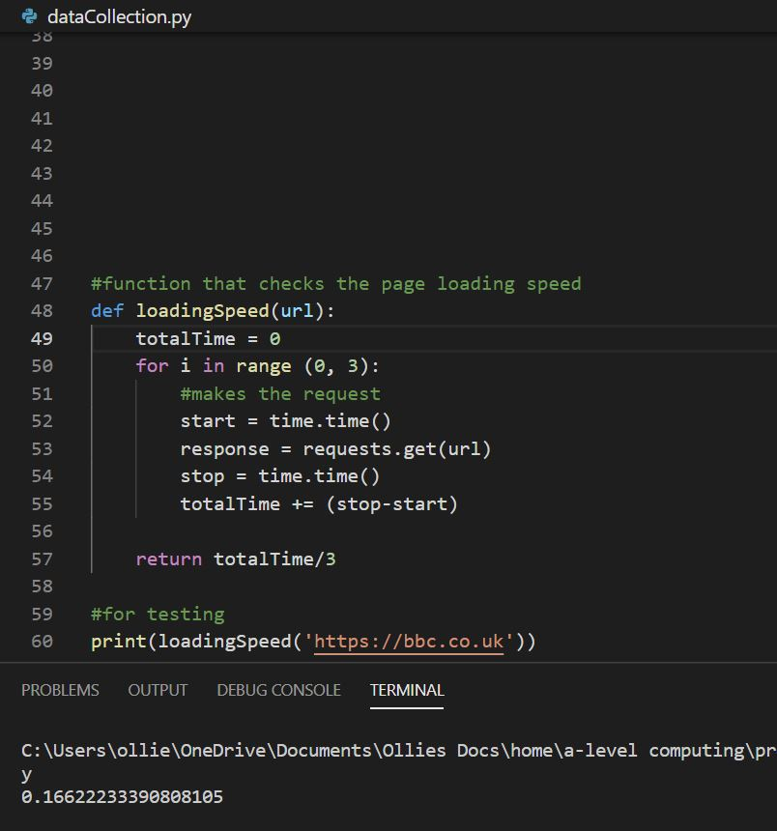However, the function returns 17 decimal places which is way too many. Since only the first 3 are important, I will round the result to 3 decimal places:

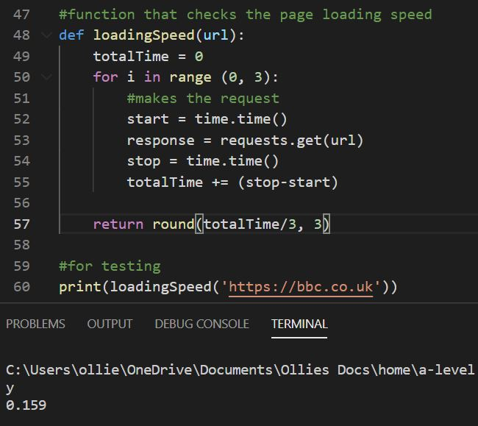This was the expected result.

Integrating this with the main Web Scraping function gave:

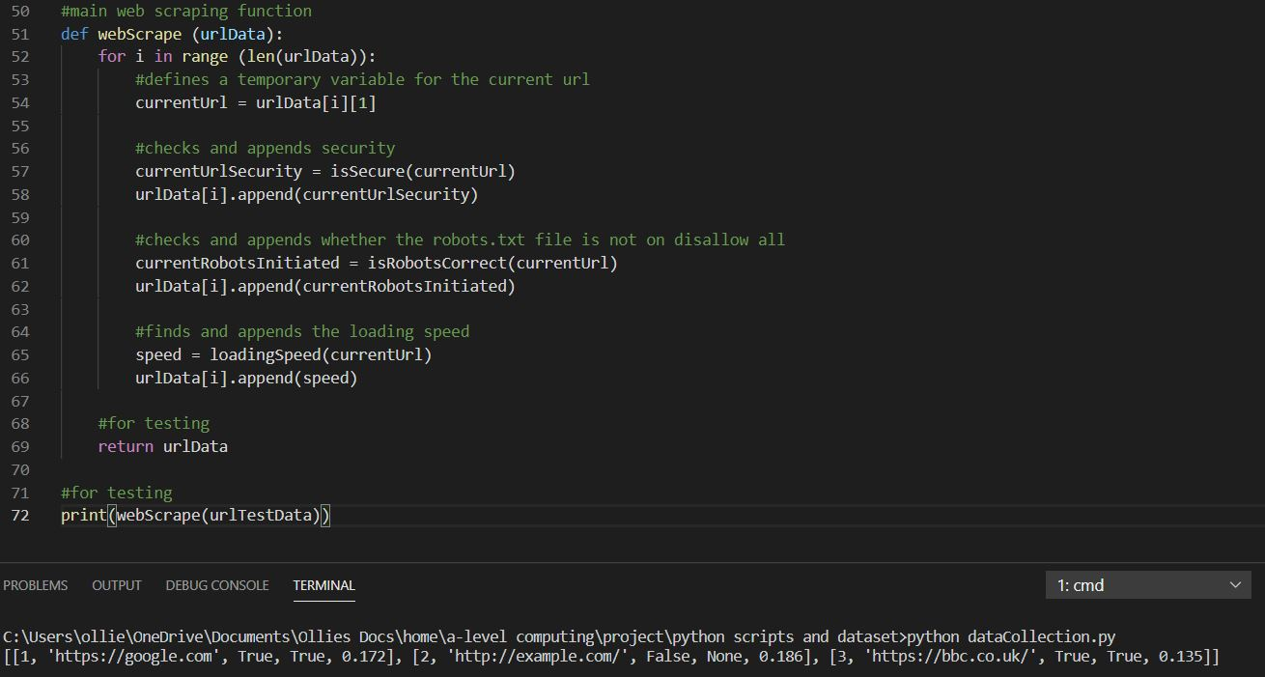

This returned the correct results.

### Web Scraping: Number of Key Words

Next, I need to program a function that will be able to find the number of key words (words in this list: short, term, short-term, lets, let, lettings, holiday, corporate, rentals, rental, bnb, bnbs, accommodation, medium-term, medium, serviced, property, properties) inside of the title tags, the h1 tags and the whole webpage.

To do this I will need a function that does the following:

1. Gets the html.
2. Splits it into words in title/h1 tags and the rest of the webpage.
3. Checks the number of keywords in each of those lists.
4. Returns that number of matches.

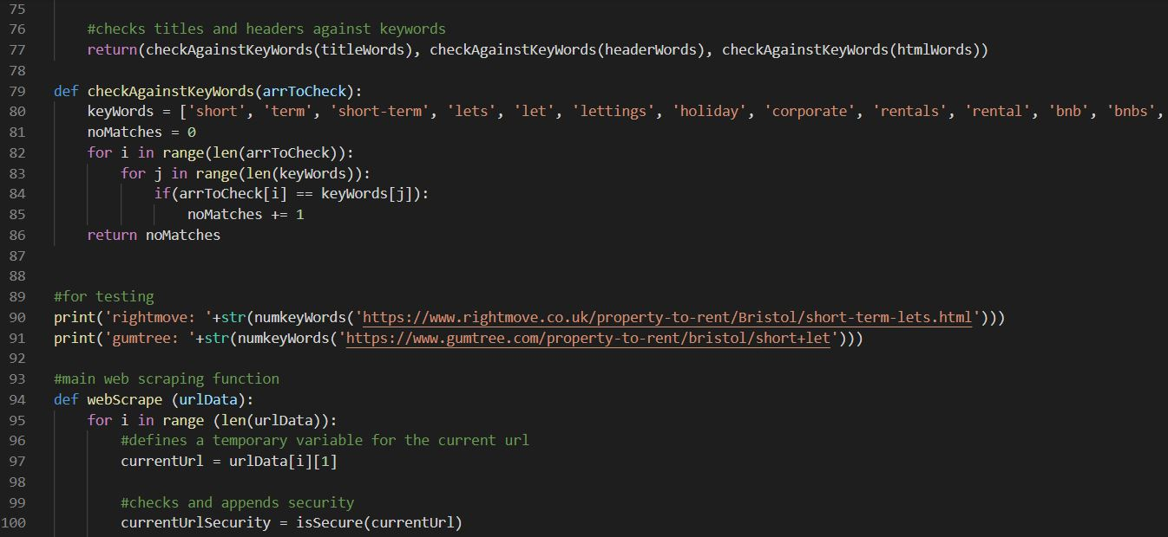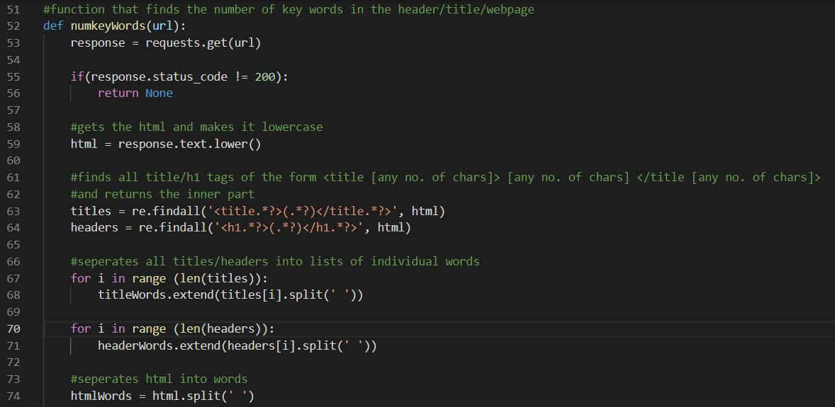My first attempt gave this:

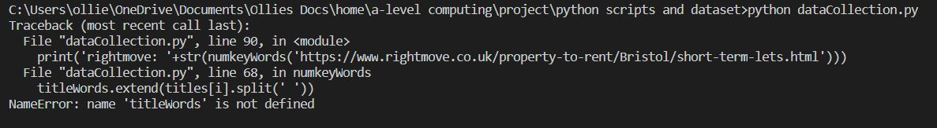and this was the error:

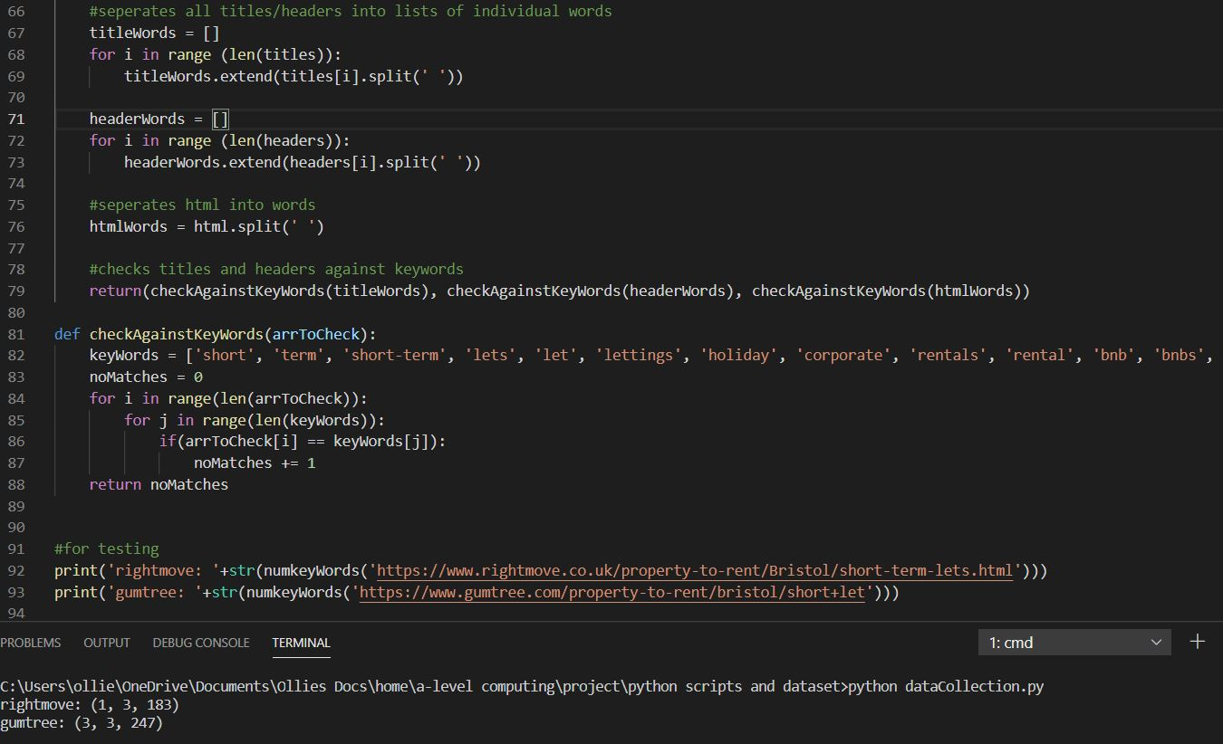 The problem is that I have not pre-defined any empty arrays to be filled with the individual words in the title / h1 tags, so implementing this before lines 67 and 70 gave:

Here, I believe the gumtree number of 247 key words was too high. After looking back through the code, I noticed that I could remove large amounts of the html that are not visible to the viewer (between script and style tags and other tags themselves). This would not only reduce the excess keywords but would speed up the whole process.

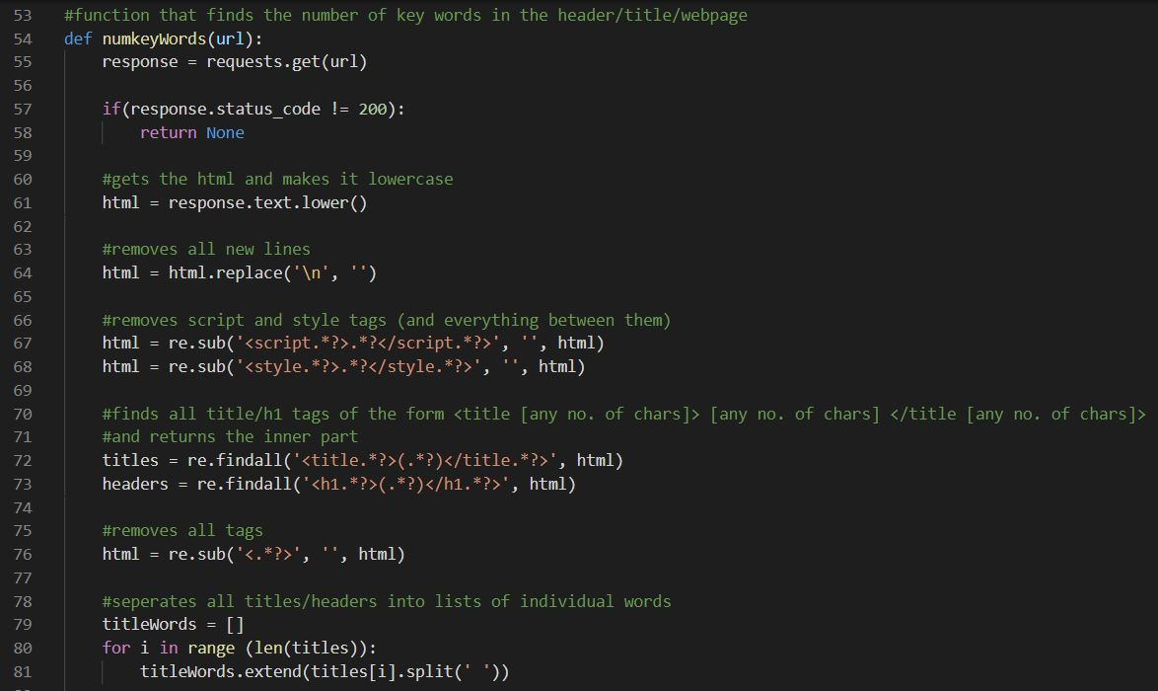Implementing this gave:

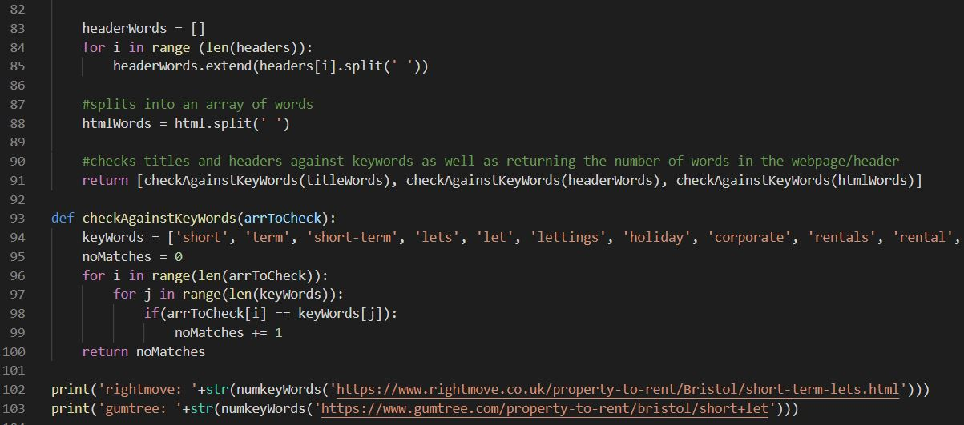

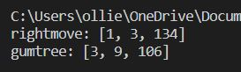 This was what was expected.

I will then call this from the main function. To test the functionality of this new function, I have increased the test dataset to include URLs that do have these key words:

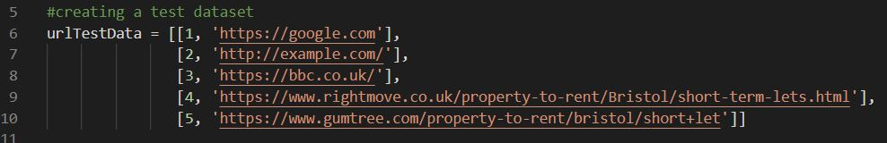

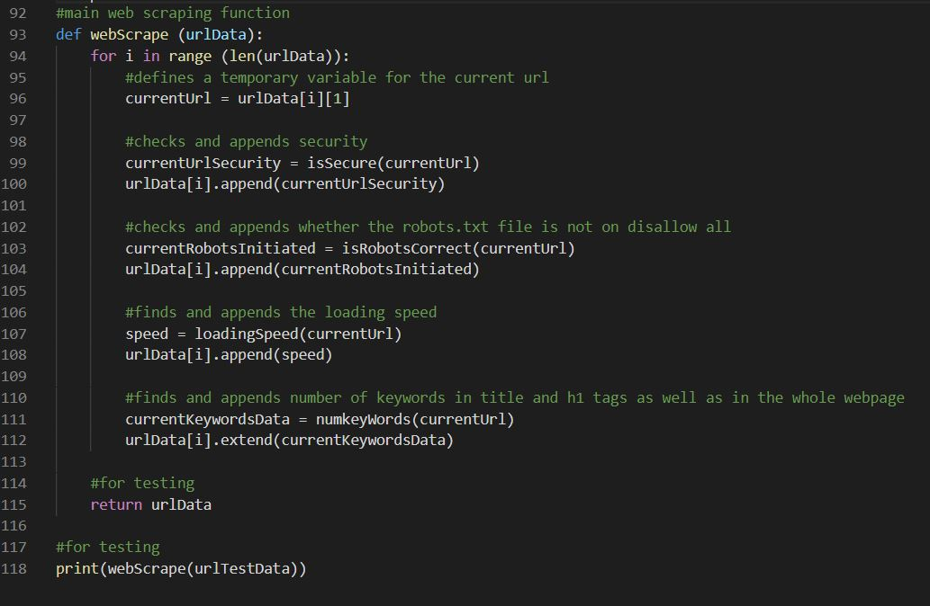Here is the main web scraping function:

Here was the output:

This is the appended array now with the number of key words in each element, which was expected.

### Web Scraping: Length of texts

Next, I need to program a function that will find the length of text in the h1 tags and the whole webpage. While this may seem like this should be its own function, in order to reduce the time taken to make a get request, I will attempt to integrate it with the previous function (since it already makes a get request for all the html).

All that was needed for this integration was to include the lengths of the arrays in the return statement:

This returned:

Which was expected.

### Web Scraping: Number of specific Tags

Next, I will need to create a function that returns the number of image, video and link tags in the html document. To do this I will create a new function however I will have it be called by the ‘numKeyWords’ function since that function has already completed a get request for the html.

To do this the inputs of the new function will be the html before I removed all tags (that were not script or style tags) and I will output an array with the number of image tags at index 0, video tags at index 1 and link tags at index 2. Similar to finding the titles and headers previously, I will use regex to look for the following patterns:

1. ‘<a’ for links
2. ‘<video’ for video
3. ‘<img’ for images

This was the new function:

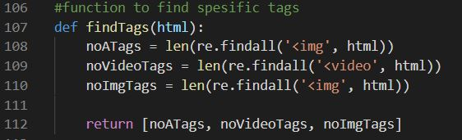

Here was where it was called:

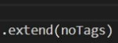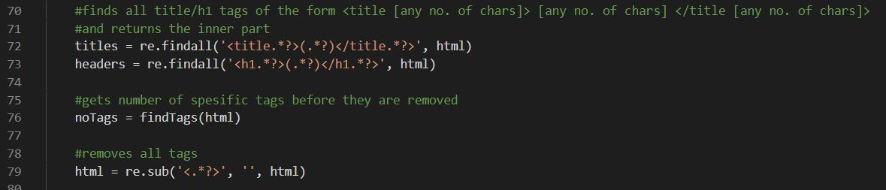Here is how it was appended to the return statement of the ‘numKeyWords’ function

And this was the error:

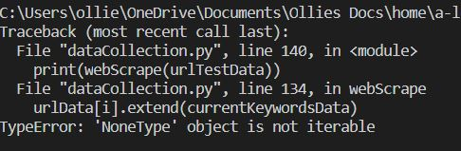

The problem here is that the extend function is applied as if it will return a value. Instead, the purpose of the extend function is to modify the array its applied to. The solution is to separate line 24 into two lines, one defining ‘output’ and another extending ‘noTags’ to it.

Another error I spotted was that line 108 which should have been finding <a> tags was looking for <img> tags. Changing these resulted in:

This was correct.

Since the outputs are starting to get longer, here is a key for every row:

[position, URL, security, robots file, loading speed, number of keywords in the title, …h1 tags, …whole webpage, length of text in the h1 tags, …whole webpage, number of <a> tags, …<video> tags, …<img> tags].

## Data Pre-processing

### Encoding Grouped Data

Since python functions are pass by reference, I can pass the web scraped dataset from the last section as a parameter to a pre-processing function without having to return the modified array after.

My first pre-processing task is to one-hot-encode grouped data. The only grouped data I have collected is the webpages security and the robots.txt file. Since both of these are currently of a Boolean datatype, I will not have to create any more columns; I can simply replace all ‘True’ values to a 1 and ‘False’ to a zero.

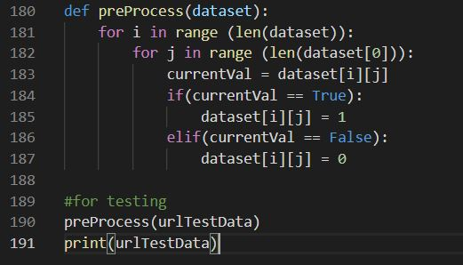This was the implemented function:

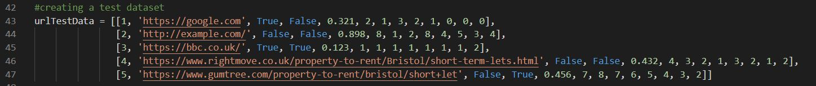To test this function, I made the test dataset have the same form as an output of the web scraping function. As shown below:

Here was the output:



Which correctly replaced the Boolean values with integers.

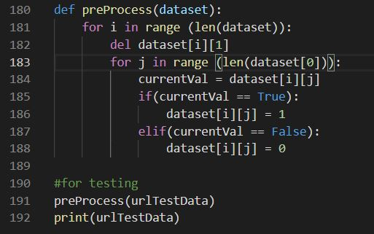Next, I need to remove the URL column since it was only used for web scraping and will not be useful for the ANN. To implement this, I will loop through every (1D) array in the 2D array and used the python keyword ‘del’ to delete the 2nd column in each of these. Since I am already looping through the array, I can simply add it to the ‘i’ loop:

Which correctly outputted:

Lastly, I need to standardize all my variables. To do this I need to calculate the means and standard deviations for all numerical features (Page loading speed, all key word numbers, all length of texts and all numbers of html tags).

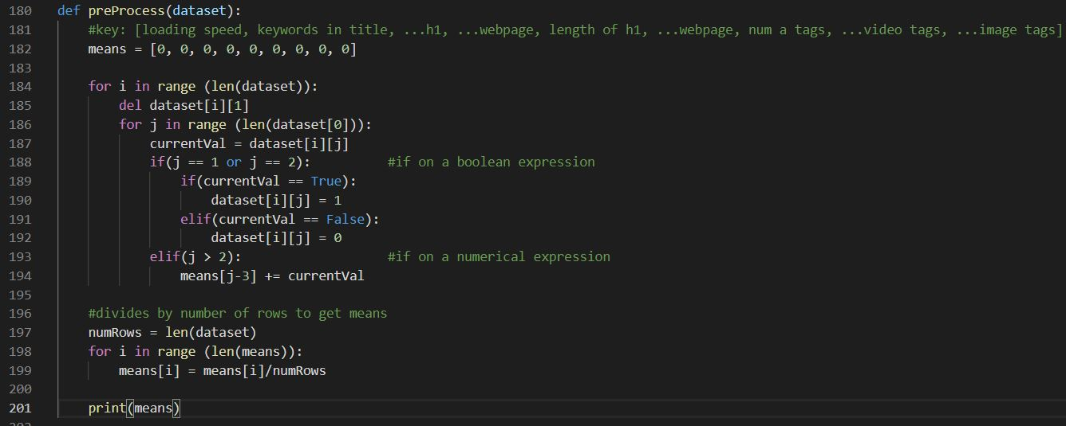To calculate these means and standard deviations, I will need to collect the sum of all these features to then calculate the mean (which can then be used to calculate the sum of the squares of the deviations from that mean to find the S.D. ). I then used an if statement to see whether the column number is a numerical data type and added up the relevant sum if so.

The output was correctly calculated averages (and the preprocessed data underneath):

To calculate the standard deviation, I am using this formula:

(sample) Standard Deviation = $\sqrt{\frac{∑{\left(\overline{x}-x_{i}\right)}^{2}}{n-1}}$

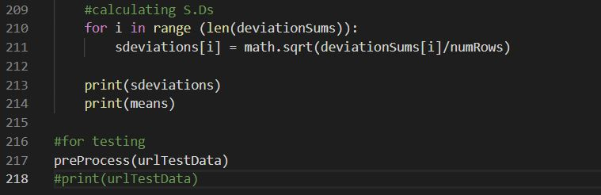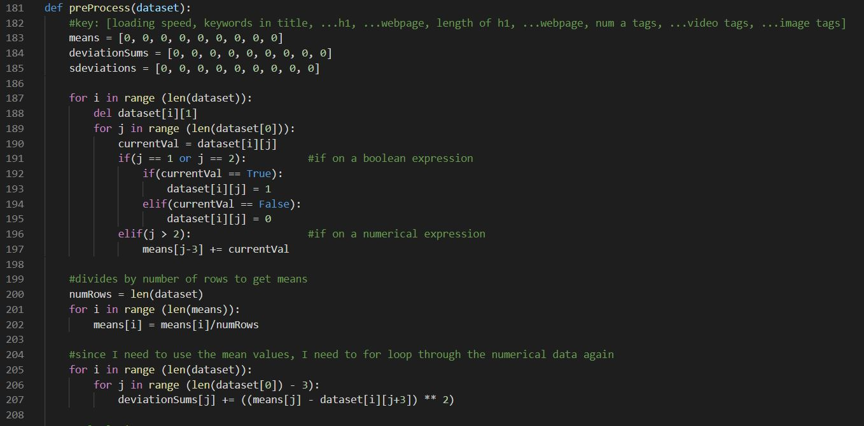To calculate this, I first calculated the sum by using nested FOR loops to go through every item of data in the 2D array ‘dataset’ and performed the calculation. I then calculated the rest of the formula in a separate FOR loop:

Here was the output (which was correct):

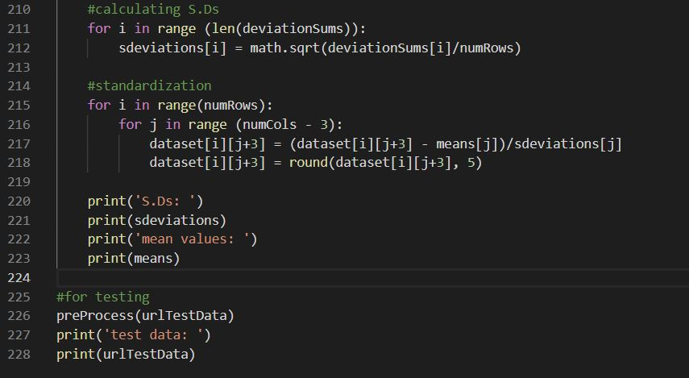Next, all I needed to do for normalization was apply the formula $z=\frac{x-μ}{σ}$, I also rounded the final values to 5 decimal places since they were too precise:

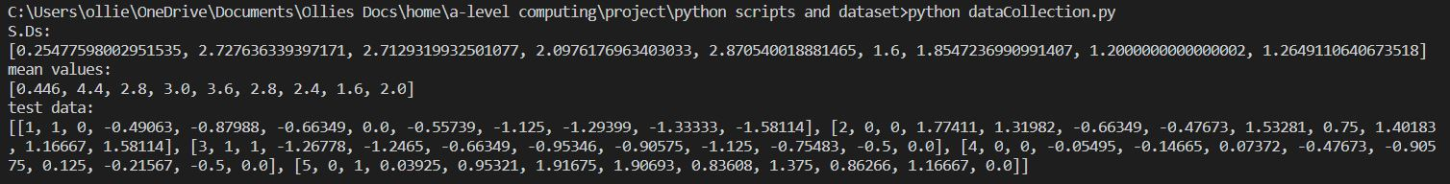Which outputted:

This output is correct.

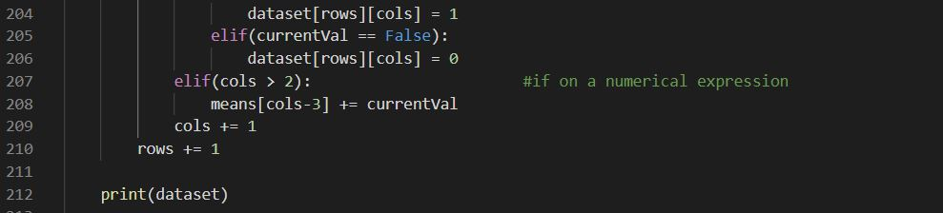Lastly, I need to remove all rows with null values. I will implement this as early (in runtime) in the program as I can as it will reduce the number of unnecessary calculations. Since I already have a loop going through every variable in ‘dataset’, I will implement a check for the ‘None’ datatype there. The one issue is, since I am no longer certain how many iterations are necessary for these loops, they can no longer be FOR loops, so I have switched them to WHILE loops with counters that I can decrease when a row/column is deleted:

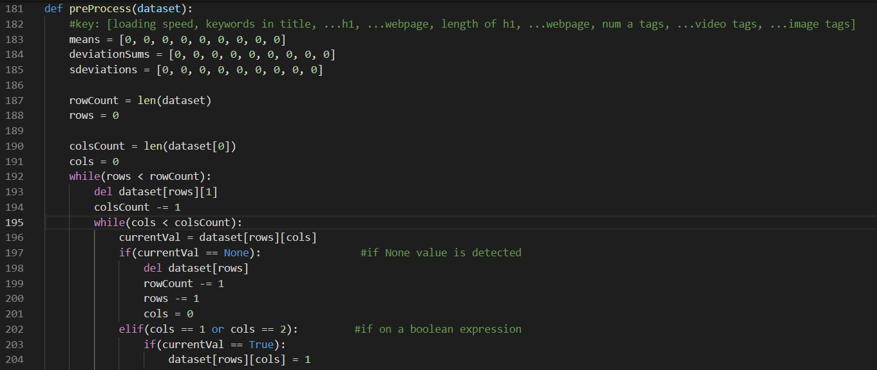

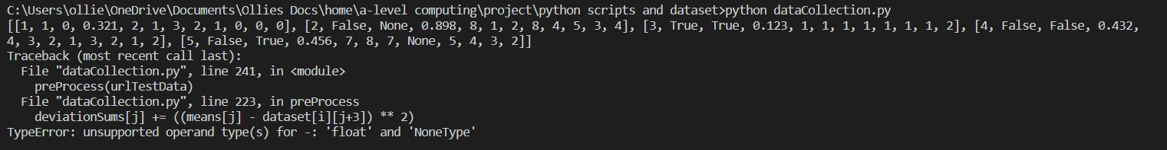And this was the output:

As can be seen in the outputted data, ‘None’ types are still there. I then found that I never set the ‘cols’ variable to zero before iterating through all columns, implementing this outputted:

As was expected.

### Outputting Data

The very last part of data pre-processing is combining all previous functions to create one dataset that my program outputs as a CSV file. To do this I will write a function that calls the correct functions in order and create and output the web scraped and processed data.

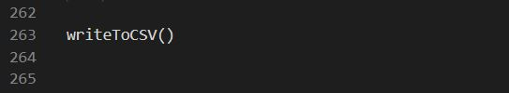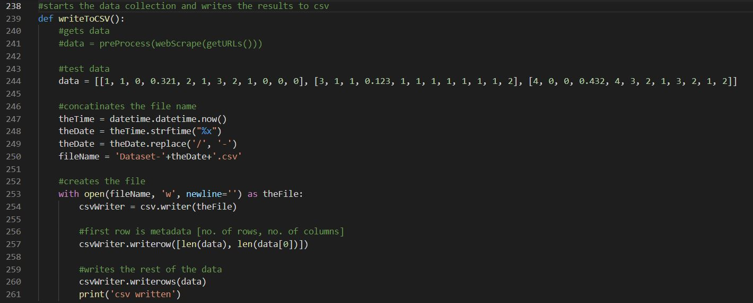In order to keep previous versions (In case of future problems with data) I will create the file with a name that includes the current date, the strftime() function converts the datetime object into a string:

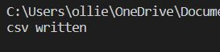

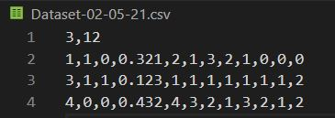This outputted:

And this file was created:

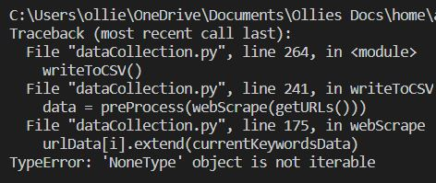Since this test data was successful, I ran this on the real dataset which returned this error:

Since ‘None’ datatypes are only taken care of during pre-processing, the solution to this error will have to keep the ‘None’ datatype involved.

I believe the problem is coming from when I use the ‘extend’ function with a list that contains a ‘None’ datatype, the result is simply ‘None’ rather than a list. To solves this, I will instead us the ‘+=’ operator which does not have this issue:

This error was due to a failed certificate verification that python runs, since I am only getting the HTML and not sending sensitive information, I can bypass this by using ‘verify = False’ in the parameters of my get requests.

My next problem was not an error, but my program did not have a timeout set, so I had to implement one. In order to do this, I needed to make use of the ‘try’ and ‘except’ keywords to catch a timeout error. This is one example of how I implemented this:

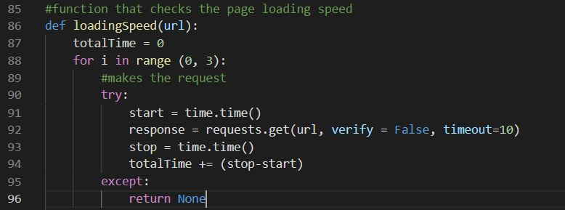

This correctly web scraped, however the next error came from pre-processing:

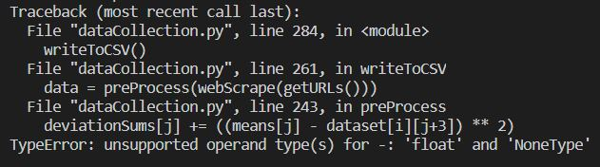

The problem here was that I was using a variable to store the number of columns which I needed to loop through to delete all ‘None’ datatypes, this resulted in my pre-processing algorithm missing the final column and not knowing how many times to iterate. To solve this, I used a single WHILE loop rather than nested for loops.

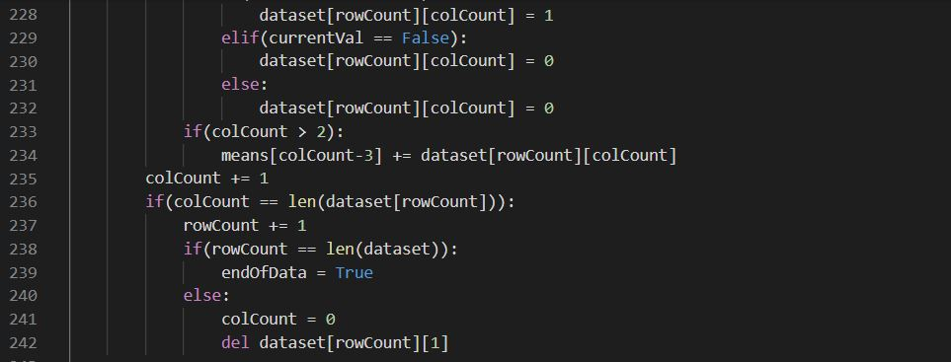The way pre-processing now takes care of ‘None’ values is by seeing if the current variable in the list (kept track of using indexing variables called ‘colCount’ and ‘rowCount’) is a ‘None’, It will immediately get rid of the row, set ‘colCount’ to zero and delete the URL in the new row. Additionally, the loop now has to check whether it should break or not after every iteration (since it is a WHILE loop). Here were the changes:

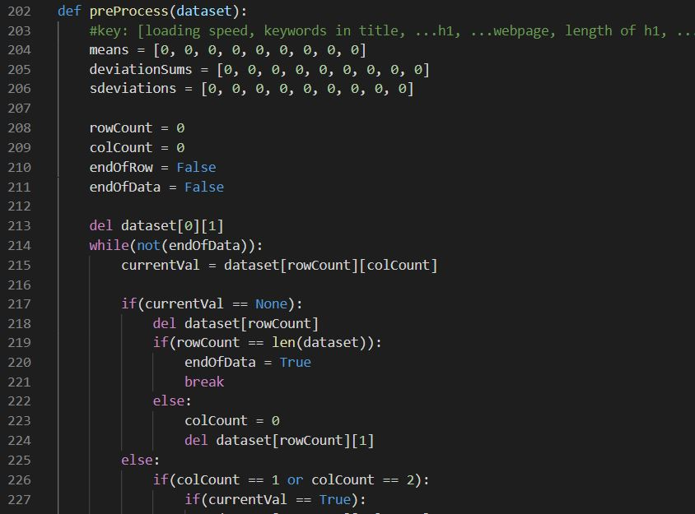

Running this algorithm with this test data:



Returned this standardized data:

Which I manually checked was correct.

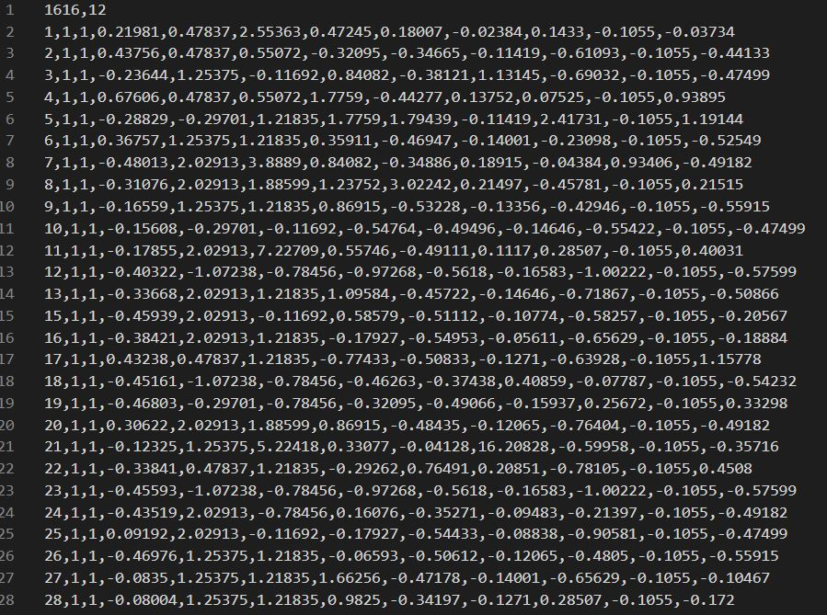Here was some of the csv that was outputted when this was implemented with the other functions:

This is the raw data that will be used to train the ANN.

## Machine Learning

### Importing Data

Firstly, I will create another python file called ‘machineLearning.py’ where I will run the machine learning algorithm. To connect the two files, I will import my ‘machineLearning’ and call my function called run().

This ‘run()’ function will act as the main machine learning function by coordinating all subroutines underneath it.

The first of these subroutines to be programmed is one to import the data. For testing I will be using ‘testcsv.csv’, using pandas read_csv() function I can create a 2D NumPy array for the data.

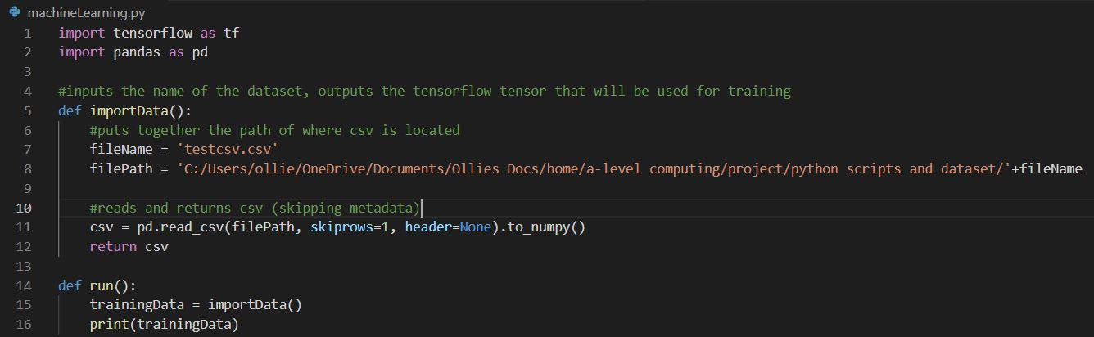Here is the code from ‘machineLearning.py’:

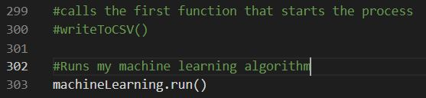Here is the code from ‘dataCollection.py’:

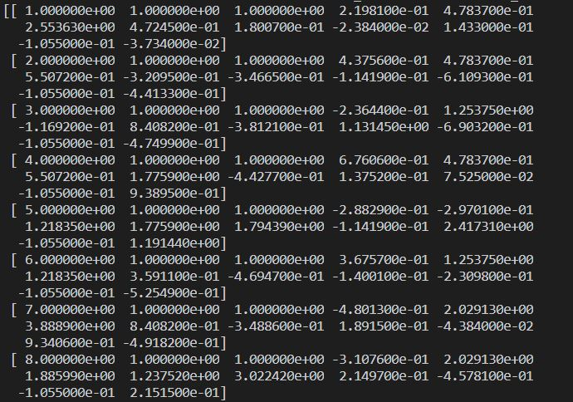And this was the start of the output:

This is the correct data in standard form notation.

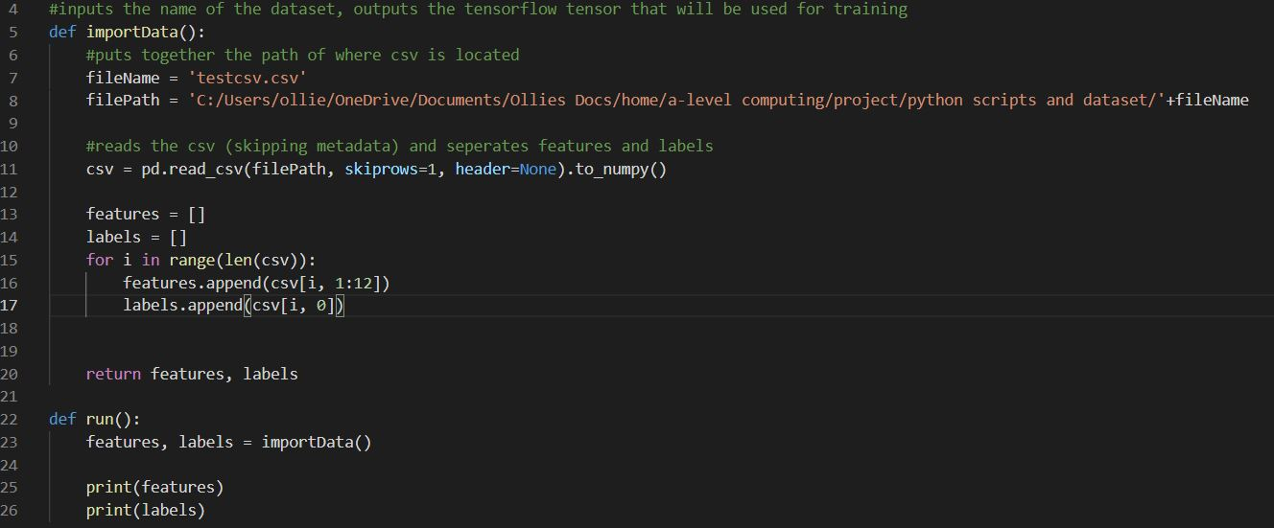Next the features and labels need to be separated, I will do this with a for loop by appending the rows of csv when sliced:

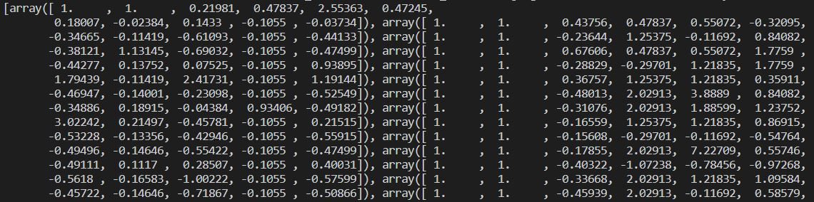The outputted features:

The outputted labels:



The test data has been correctly imported.

### Create the Untrained Neural Network Model

To create the untrained model, inside a new function I defined the model and added the layers. The input shape is a required parameter for the input layer, for the hidden layers, since they are all of the same type, I added the layers in a for loop, finally the last (output) layer has only one node (the URL’s position):

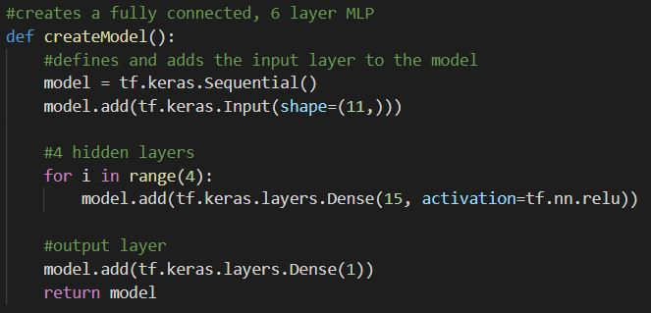

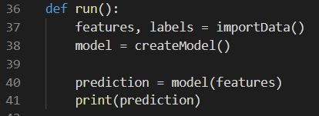

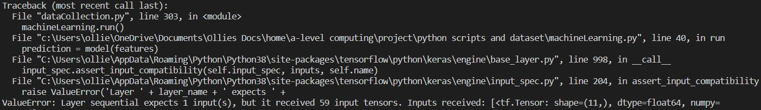Here was the error:

The problem here is that the model is treating every row of features like a tensor when it should be a NumPy array since ‘keras’ models use NumPy arrays instead of python lists (fchollet, 2020). The simple fix is to make the features and labels NumPy arrays, I will do this in ‘importData()’:

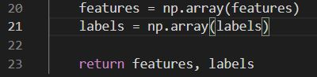

This returned:

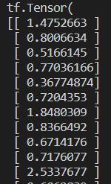

Obviously, these predictions are incorrect because the model has not been trained, however the model has been created and produces output, so this function is successful.

### Training

Training is when the features are passed into the model in batches, the outputs are calculated which are used to calculate the loss and gradients for all the weights and biases which are then adjusted, this is repeated on the whole dataset for many epochs.

To implement this, a new function is required that inputs the model and training data and will eventually output the trained model. TensorFlow’s ‘model.fit()’ function will work for the first iteration of development, this function performs the training loop given a set of hyperparameters:

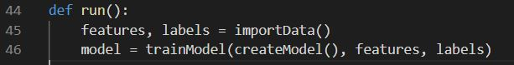

The output:

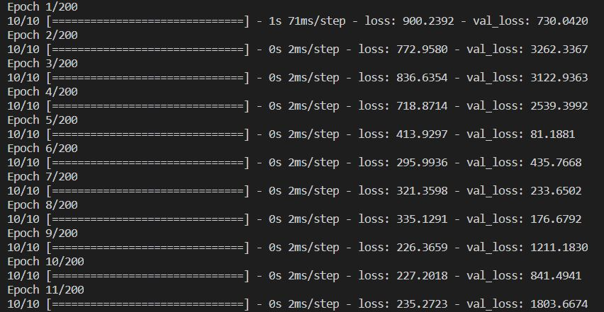

initially the loss (a measure of error) decreases which is what we want, however by the end we can see the training loss (or just ‘loss’ above) is far lower than the unseen validation loss (or ‘val_loss’). This is a sign of overfitting and the solution involves reducing the number of epochs and increasing the amount of data.

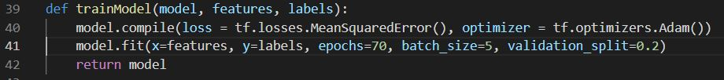Since I am happy that the model is learning, I will now change the program to use the entire dataset rather than the testing one. After trial and error with the different hyperparameters, 70 epochs with the ‘Adam’ optimizer gave me the best results that did not overfit:



Additionally, I saved the model:

# **Evaluation**

## Success Criteria

Here is a brief outline of the success criteria I did and did not reach:

|  |  |  |
| --- | --- | --- |
| **Number** | **Criteria** | **Reached** |
| 1.1 | * Requirement to collect at least 100 records of data. * With at least 10 fields for each. | Yes |
| 1.2 | * All rows of data with null values must be deleted. * All categorical data must be encoded to numbers. | Yes |
| 2.1 | * A trained neural network | Yes |
| 3.1 | * A way of showing the predicted ranking to the user. * The option to update the prediction in less than a minute. | No |
| 3.2 | * A search engine embedded into my webpage that allows users to perform a search. | No |
| 3.3 | * Ability to add another webpage to one account. | No |
| 4.1 | * A way of creating an account. * A way to login to an account. | No |
| 4.2 | * A database that is linked to my websites backend that stores a User ID, Username, and password hash. | No |

### 1.1

My evidence of this completion is outlined in the analysis section to be screenshots of the database containing more than 10 columns and 100 rows. Here are the screenshots:

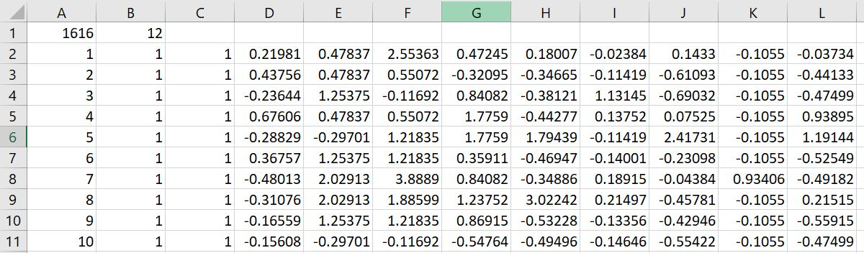The first shows the top ten rows, clearly showing 12 fields of data which is greater that the necessary 10 fields.

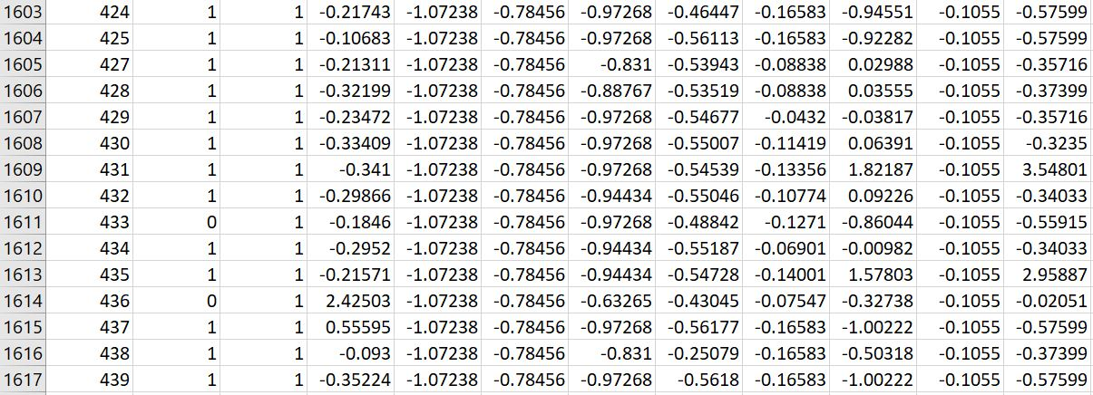The second shows the last few rows which can be seen going down to the 1617th row, which is far greater than the necessary 100 rows.

### 1.2

The necessary evidence for criteria 1.2 is screenshots showing encoded values without null data.

In screenshot of the first ten rows, it is obvious that column ‘B’ and ‘C’ are encoded with 1 = true and 0 = false. Additionally, no cells show null values, as was necessary for the success criteria.

### 2.1

The necessary evidence for criteria 2.1 is a screenshot of a prediction being made from the network.

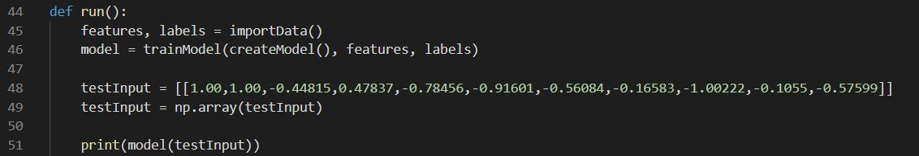This was the code that made the prediction based on the input on line 48:

Here is the actual prediction, predicting 201st on the SERP.

### 3.1 to 3.3

Unfortunately, I was unable to meet these success criteria due to the coronavirus pandemic which limited my ability to develop the user interface (my website) on which these success criteria relied. While I am aware that this means that my stakeholders cannot benefit from the functionality of predicted rankings, an embedded search engine and multiple webpages on one account (as was outlined in my design), hopefully these features can be developed in the future so that the software which I have developed can be used by my stakeholders, creating fully complete system.

The evidence for success criteria **3.1** is screenshots of both the predicted ranking on my website and a timer showing less than on minute to refresh, I cannot provide these since I have not developed the website, however for the software that I have developed, rankings can be predicted in less than a minute, although I am aware that this does not take internet speed and server speed into account as this success criteria was supposed to.

The evidence for success criteria **3.2** is screenshots of a search engine embedded into my website, again I am unable to provide these due to the fact that my website has not been developed. However, in the future I will include this when the website is developed, it will likely be done using Google’s ‘Custom Search Engine’ since it is a very popular search engine for the general public and therefore the most useful for my stakeholders.

The evidence for success criteria **3.3** is screenshots of a button with the option to add another webpage to my account, again this cannot be provided since the website has not been developed, however in the future I will develop this, most likely using the button HTML tag which will send a request to my server that will need to add data to my database.

### 4.1 to 4.2

As previously mentioned, unfortunately I was unable to meet these success criteria due to the coronavirus pandemic which limited my ability to develop the user interface (my website) on which these success criteria relied. While I am aware that this means that my stakeholders cannot benefit from my user interface features such as the ability to login and a database that correctly stores their information (as I outlined in my design), hopefully these features can be developed in the future so that the software which I have developed can be used by my stakeholders, creating fully complete system.

The evidence for success criteria **4.1** is screenshots of a sign-up page, a login page, and the page after a login page, these cannot be provided due to the website not being developed, however I have fully designed the UI for these components and so in the future I will implement those designs using HTML, CSS and JavaScript.

The evidence for success criteria **4.2** is screenshots of a database with fields for user ID, username, and password hash, these cannot be provided since I have not developed the database which is required for the websites backend. In the future I will implement this so that my websites backend communicates with the SQL database when the sign-up form is submitted.

## Post Development Testing

Referring back to my design where I designed post development for my stakeholders. Since my software development was cut short, I cannot use these scenarios exactly as I had planned due to the fact that the relied on the user interface. In order to carry out testing on all that I have completed so far, I need to change this test plan to the following:

* Generate a trained machine learning model which has been trained on Google’s search results to predict a URLs position.

To do this, all I had to do was change the file name in ‘machineLearning.py’ to today’s date:

and initiate the process using this command:

After it had finished running, the saved model appeared in my ‘models’ file:



This shows that all of my code so far works correctly. In the future when I have finished all success criteria, I will give the finished product to my stakeholders to perform the original scenarios outlined in my design stage.

## Limitations

My current systems limitations are outlined in the success criteria which I did not fulfill, specifically the user interface (website) is not built, the reason for this, as previously mentioned was the COVID pandemic effecting how I developed this project. The main effect this limitation has is in limiting how my stakeholders interact with my current application, but in the future this user interface will be built so that my stakeholders can make use of my software.

My finished system will have a number of limitations too. These are limitations that impact my solutions ability to solve the problem I outlined in my ‘Analysis’ section. The first being for my backend, when my system is complete, I will have to run the program ‘dataCollection.py’ periodically so my neural network can be as time accurate as possible (and not get outdated by Google’s algorithm), since this is not fully automated, it is one limitation of my system. One way to overcome this is by in the future, using my computers built in operating system scheduling features which can run the code every month.

Additionally, another limitation is that I make use of web scraping to collect data from each webpages HTML, it is known that websites change their structure regularly (Phoenix, 2020), and so in the future my web scraping algorithm may no longer work. While this can be solved with attention and maintenance, however it does mean my system is more fragile, which is another way my system is limited.

Another limitation is that my neural network and therefore website predictions rely on the fact that my stakeholders’ users are using Google as opposed to another search engine such as Bing or Yahoo, if this is the case then my predictions will be incorrect since they are trained on data from Google. In the future, this can be solved by me creating many different neural networks, trained on data from different search engines so that the system can be as inclusive as possible and appeal to as many different people as possible.

## Maintenance

In the short term, no maintenance is required except weekly checks to see if my system is working correctly, this includes if the login/signup system is working and if predictions are refreshing. I will carry out these checks using the post development testing I outlined in ‘Design’. If I do detect a problem, then I will need to fix all bugs detected as fast as possible. This is important because if my server goes down, then my stakeholders will not be able to get predictions which may impact their website development process.

However, in the medium/long term, every month I will run my ‘dataCollection.py’ python script which should collect the newest data and then trigger the ‘machineLearning.py’ script to train a new model which will then be used for that month’s predictions. My reason for doing this is so that my predictions do not become outdated; Googles algorithm changes consistently, in 2020 it is estimated that they change it 12 times (MOZ, 2021) which is roughly once every month, so to stay as relevant as possible, this is required.

## Future Development

As stated above in my success criteria breakdown, I still have the front-end UI and the database to implement before the system is ready for stakeholders to interact with it normally.

More specifically, I must implement the ‘login/signup’ page I designed earlier in my project, this should be hosted on my own server which is connected to a database for every account. I need to implement the ‘predicted rankings and SERP’ page which I also designed earlier, this includes the ‘refresh’ button which will make a request to my server, my server will then run the web scraped data from their website through my neural network to get a prediction, and if this prediction is different to the one on the front-end, then it will update.

The ‘add new web page’ button is also part of this webpage; it needs to send a request to the server which will web scrape data on the new webpage and store it in the database. Lastly, the search engine results page, which will be Google’s search engine since it’s the most relevant, I will use a Google Custom Search Engine which will give me the HTML to add to the webpage.

Other future developments include improving my data collection algorithm to collect different features or more features for web scraping so that my neural network has more data to draw more accurate predictions. Implementing this would improve success criteria **1.1** and **2.1**.

Additionally, I may make use of my computers built in operating system scheduling features which can run the ‘dataCollection.py’ script every month, thereby reducing the reliance on human interaction, reducing the number of human errors such as forgetting to run the code. This would fully automate the system and take out some of the maintenance that I currently do.

Lastly, I may web scrape different search engines other than google and create neural networks for these other search engines as well as implement the option for my stakeholders to choose which search engine the rankings are based off. This will increase the range of people my software appeals to and make the experience more user specific.

## My Code

### dataCollction.py

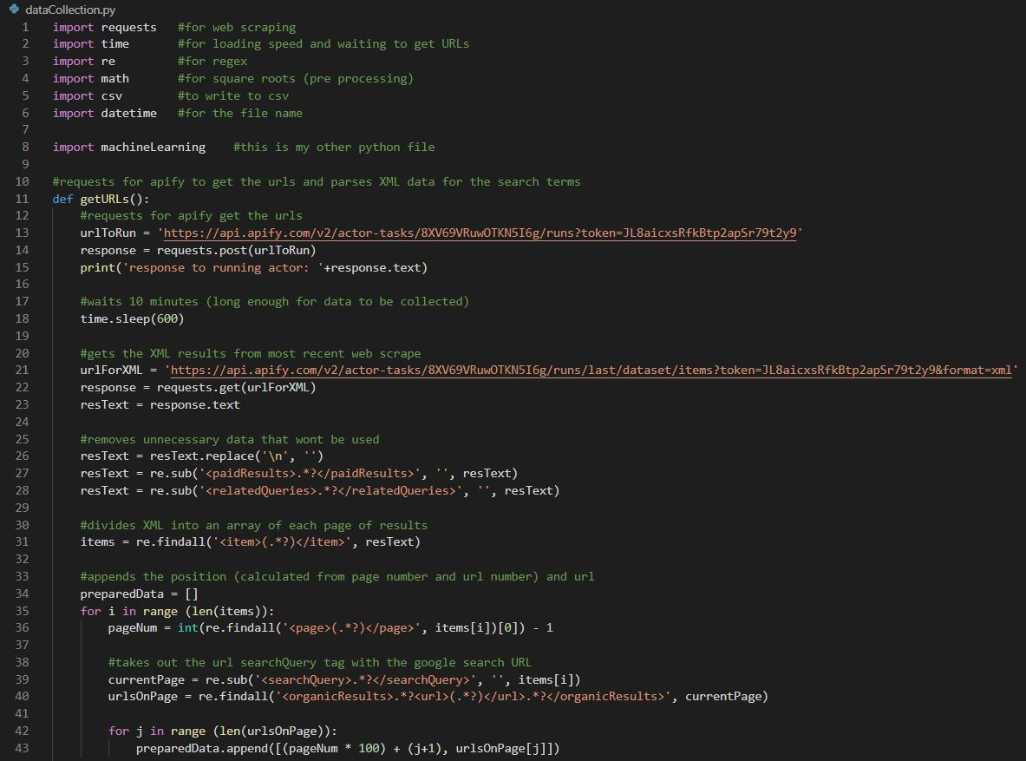

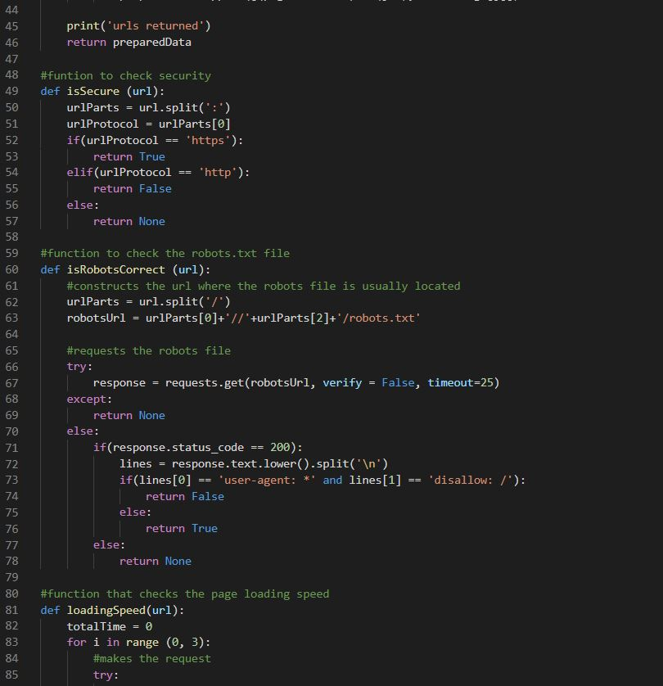

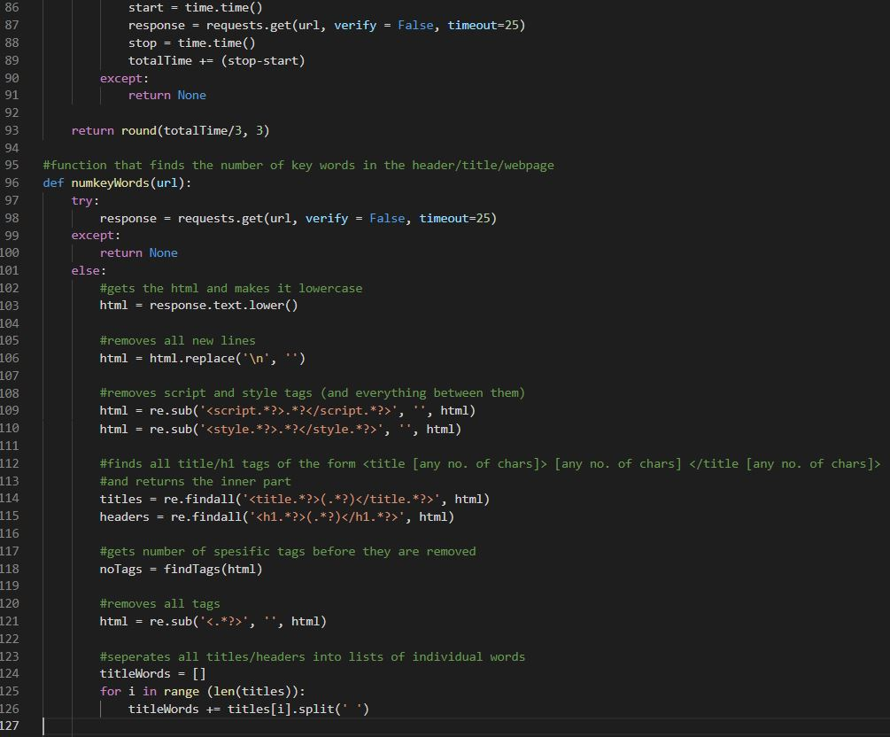

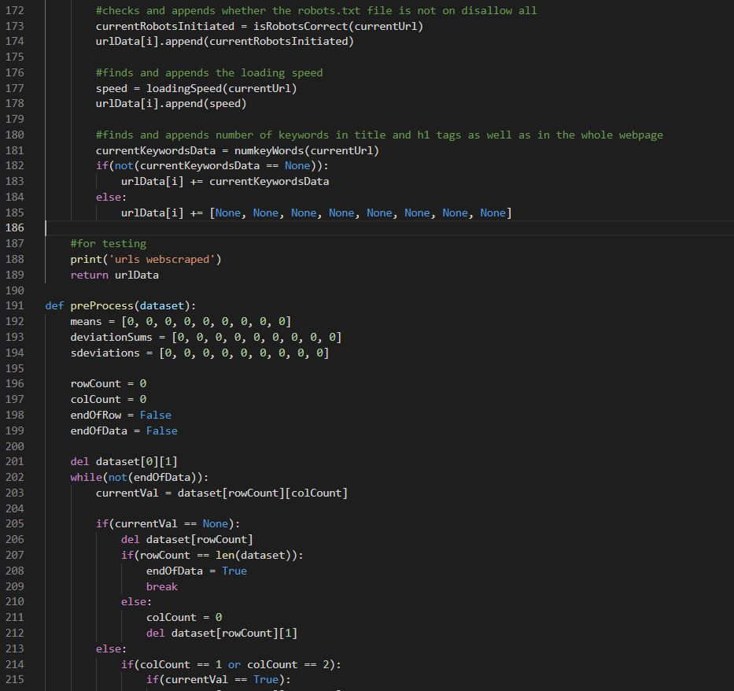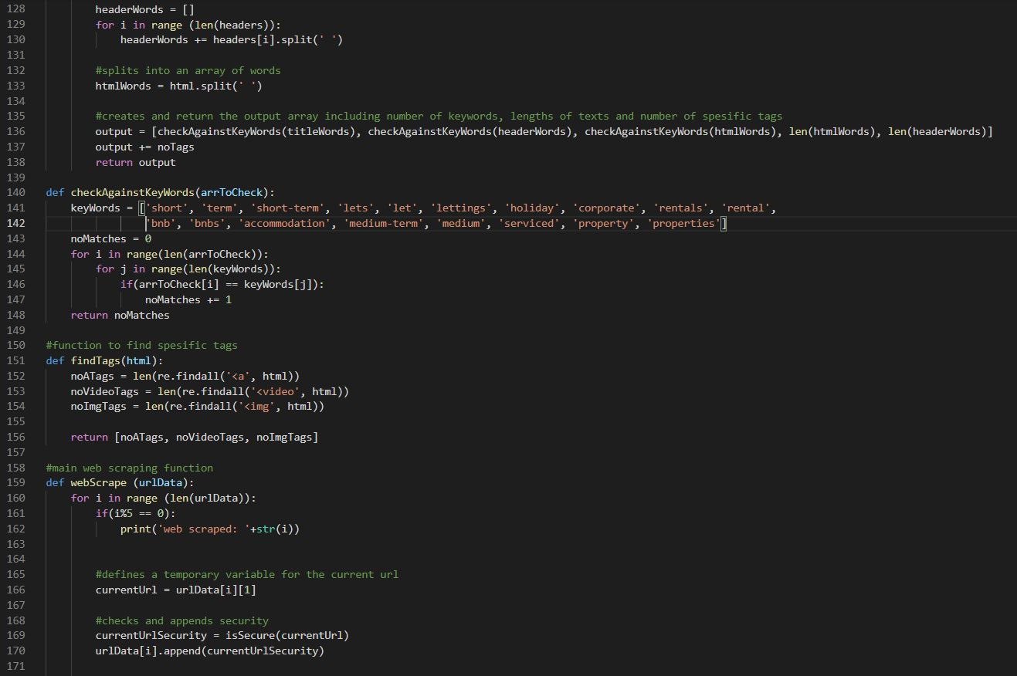

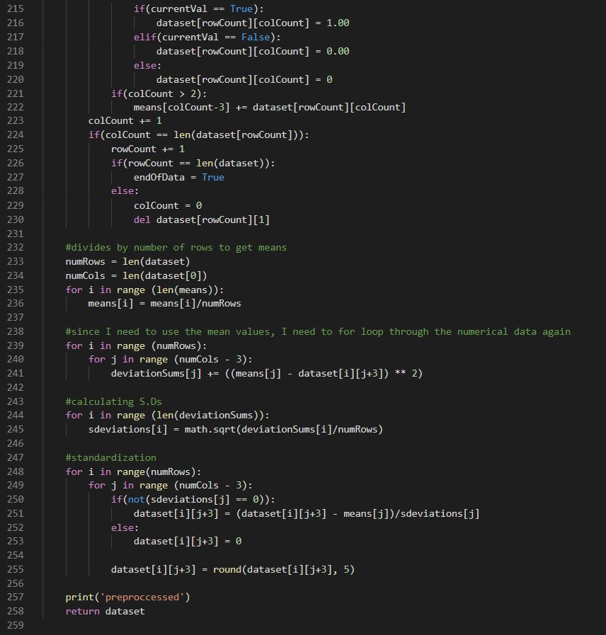

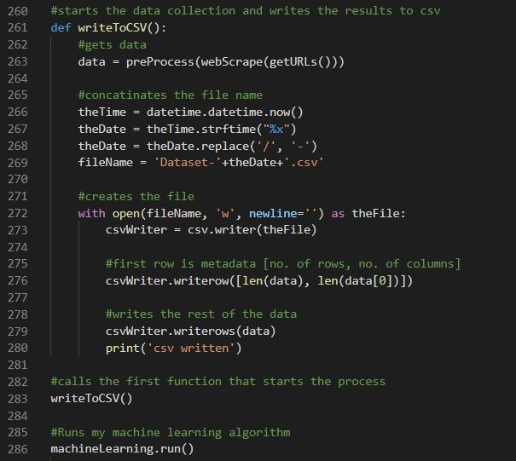

### Text Description automatically generatedmachineLearning.py

# References

Bhandari, P., 2020. *The standard normal distribution.* [Online]   
Available at: https://www.scribbr.com/statistics/standard-normal-distribution/  
[Accessed 13 January 2021].

Brownlee, J., 2016. *Supervised and Unsupervised Machine Learning Algorithms.* [Online]   
Available at: https://machinelearningmastery.com/supervised-and-unsupervised-machine-learning-algorithms/  
[Accessed 14 January 2021].

CanIRank, n.d. *Beyond Keyword Difficulty: Competitive Analysis for SEO.* [Online]   
Available at: https://www.youtube.com/watch?v=LhgIMJmNAmc&feature=emb_logo&ab_channel=CanIRank%3F  
[Accessed 10 11 2020].

CanIRank, n.d. *CanIRank Homepage.* [Online]   
Available at: https://www.canirank.com/  
[Accessed 09 11 2020].

Clement, J., 2020. *Worldwide desktop market share of leading search engines from January 2010 to October 2020.* [Online]   
Available at: https://www.statista.com/statistics/216573/worldwide-market-share-of-search-engines/  
[Accessed 28 December 2020].

Cook, J. D., 2013. *Can regular expressions parse HTML or not?.* [Online]   
Available at: https://www.johndcook.com/blog/2013/02/21/can-regular-expressions-parse-html-or-not/  
[Accessed 24 May 2021].

Dertat, A., 2017. *Applied Deep Learning - Part 1: Artificial Neural Networks.* [Online]   
Available at: https://towardsdatascience.com/applied-deep-learning-part-1-artificial-neural-networks-d7834f67a4f6  
[Accessed 2 January 2020].

DTREG, n.d. *Decision Trees Compared to Regression and Neural Networks.* [Online]   
Available at: https://www.dtreg.com/methodology/view/decision-trees-compared-to-regression-and-neural-networks  
[Accessed 14 January 2021].

Elite Data Science, n.d. *Overfitting in Machine Learning: What It Is and How to Prevent It.* [Online]   
Available at: https://elitedatascience.com/overfitting-in-machine-learning  
[Accessed 8 November 2020].

fchollet, 2020. *Introduction to Keras for Engineers.* [Online]   
Available at: https://keras.io/getting_started/intro_to_keras_for_engineers/  
[Accessed 6 April 2021].

Knauff, J., 2020. *How Long SEO Takes.* [Online]   
Available at: https://www.searchenginejournal.com/seo-101/how-long-seo-takes/  
[Accessed 29 10 2020].

Kumar, D., 2018. *Introduction to Data Preprocessing in Machine Learning.* [Online]   
Available at: https://towardsdatascience.com/introduction-to-data-preprocessing-in-machine-learning-a9fa83a5dc9d  
[Accessed 12 January 2020].

Kumar, N., 2019. *Advantages and Disadvantages of Decision Trees in Machine Learning.* [Online]   
Available at: http://theprofessionalspoint.blogspot.com/2019/02/advantages-and-disadvantages-of.html  
[Accessed 14 January 2021].

Kumar, S., 2018. *How to store a password in database?.* [Online]   
Available at: https://www.geeksforgeeks.org/store-password-database/  
[Accessed 15 January 2021].

Loukas, S., 2020. *Everything you need to know about Min-Max normalization: A Python tutorial.* [Online]   
Available at: https://towardsdatascience.com/everything-you-need-to-know-about-min-max-normalization-in-python-b79592732b79  
[Accessed 13 January 2021].

McCaffrey, J., 2014. *How To Standardize Data for Neural Networks.* [Online]   
Available at: https://visualstudiomagazine.com/articles/2014/01/01/how-to-standardize-data-for-neural-networks.aspx  
[Accessed 13 January 2021].

MDN Web Docs, 2020. *Concurrency model and the event loop.* [Online]   
Available at: https://developer.mozilla.org/en-US/docs/Web/JavaScript/EventLoop  
[Accessed 24 December 2020].

MOZ, 2021. *Google Algorithm Update History.* [Online]   
Available at: https://moz.com/google-algorithm-change  
[Accessed 3 May 2021].

Phoenix, J., 2020. *The Advantages & Disadvantages of Web Scraping Data.* [Online]   
Available at: https://understandingdata.com/the-advantages-disadvantages-of-web-scraping-data/  
[Accessed 2 May 2021].

RNIB, 2015. *How to choose colour and contrast for printed.* [Online]   
Available at: http://scdg.org.uk/wp-content/uploads/2019/02/Colour-information-with-header-sheet-2.pdf  
[Accessed 9 April 2021].

SAS, n.d. *Machine Learning What it is and why it matters.* [Online]   
Available at: https://www.sas.com/en_gb/insights/analytics/machine-learning.html  
[Accessed 8 November 2020].

Sharma, S., 2017. *Activation Functions in Neural Networks.* [Online]   
Available at: https://towardsdatascience.com/activation-functions-neural-networks-1cbd9f8d91d6  
[Accessed 15 15 2021].

Talabis, M. R. M., 2015. *Supervised Learning.* [Online]   
Available at: https://www.sciencedirect.com/topics/computer-science/supervised-learning  
[Accessed 14 January 2021].

techopedia, n.d. *Web Scraping.* [Online]   
Available at: https://www.techopedia.com/definition/5212/web-scraping  
[Accessed 29 10 2020].

TensorFlow, 2021. *Install TensorFlow 2.* [Online]   
Available at: https://www.tensorflow.org/install  
[Accessed 22 May 2021].

Thompson, N., 2020. *10 Crucial SEO Ranking Factors You Need to Know.* [Online]   
Available at: https://optinmonster.com/seo-ranking-factors/  
[Accessed 11 January 2021].

w3schools, n.d. *Machine Learning - Decision Tree.* [Online]   
Available at: https://www.w3schools.com/python/python_ml_decision_tree.asp  
[Accessed 14 January 2021].

w3schools, n.d. *Machine Learning - Train/Test.* [Online]   
Available at: https://www.w3schools.com/python/python_ml_train_test.asp  
[Accessed 13 January 2021].